PRD: All Patients Refill Worklist

# PRD: All Patients Refill Worklist

# Product Requirements Document (PRD)

# All Patients & Refill Worklist

| **Document Info** |  |
| --- | --- |
| **Product Name** | Ignite MedRefills |
| **Version** | 1.0 |
| **Date** | January 3, 2026 |
| **Author** | Product Head |
| **Status** | APPROVED FOR DEVELOPMENT |
| **Confidentiality** | Internal Use Only |

## Table of Contents

1. Executive Summary
2. Product Vision & Strategy
3. Target Users & Personas
4. Problem Statement
5. Goals & Success Metrics
6. User Stories & Requirements
7. Functional Requirements
8. Non-Functional Requirements
9. System Architecture
10. Data Requirements
11. AI/ML Requirements
12. UI/UX Requirements
13. Integration Requirements
14. Release Plan & Roadmap
15. Risks & Mitigation
16. Appendices

## 1. Executive Summary

### 1.1 Product Overview

**Ignite MedRefills** is an AI-powered medication adherence management platform designed for Medicare Advantage (MA) health plans. The product enables pharmacists and care coordinators to proactively manage medication refills for patients taking chronic medications, with the goal of improving CMS STARS quality ratings and patient health outcomes.

### 1.2 Business Case

| Challenge | Current State | With Ignite MedRefills |
| --- | --- | --- |
| **Medication Adherence** | 50% of patients non-adherent | Target: 80%+ adherence |
| **STARS Ratings** | 3-star average | Target: 4.5+ stars |
| **Staff Productivity** | 15-20 refills/hour | Target: 50+ refills/hour |
| **Safety Misses** | Variable (human error) | Target: 0% AI-flagged safety events |

### 1.3 Key Value Propositions

1. **70% Automation Rate**: AI pre-approves routine refills, freeing staff for complex cases
2. **3-Tier AI Safety Net**: Primary AI → QA AI → Manager AI ensures 0% safety misses
3. **Proactive Identification**: System identifies at-risk patients before they run out of medication
4. **CMS STARS Alignment**: Built around MAC, MAD, MAH quality measures
5. **Complete Audit Trail**: Clinical Memory captures every decision for compliance

### 1.4 Scope

This PRD covers two interconnected modules:

| Module | Description |
| --- | --- |
| **All Patients (CRM)** | Central patient repository with demographics, medications, and adherence metrics |
| **Refill Worklist** | Operational workflow for processing medication refills through AI review to fulfillment |

## 2. Product Vision & Strategy

### 2.1 Vision Statement

*“To be the world-class AI-first medication adherence platform that enables healthcare organizations to achieve 100% of their CMS STARS goals while ensuring every patient gets the right medication at the right time.”*

### 2.2 Strategic Pillars

┌─────────────────────────────────────────────────────────────────────────────────┐  
│ STRATEGIC PILLARS │  
├─────────────────────────────────────────────────────────────────────────────────┤  
│ │  
│ ┌───────────────┐ ┌───────────────┐ ┌───────────────┐ ┌───────────────┐ │  
│ │ AI-FIRST │ │ PROACTIVE │ │ PATIENT- │ │ STARS │ │  
│ │ AUTOMATION │ │ OUTREACH │ │ CENTRIC │ │ FOCUSED │ │  
│ │ │ │ │ │ │ │ │ │  
│ │ • 70% auto- │ │ • Identify │ │ • Patient │ │ • MAC, MAD, │ │  
│ │ approved │ │ before │ │ portal │ │ MAH aligned │ │  
│ │ • 3-tier AI │ │ runout │ │ • SMS/Email │ │ • PDC ≥80% │ │  
│ │ decision │ │ • Risk-based │ │ outreach │ │ target │ │  
│ │ • Human │ │ priority │ │ • Barrier │ │ • Gap days │ │  
│ │ verified │ │ │ │ resolution │ │ tracking │ │  
│ └───────────────┘ └───────────────┘ └───────────────┘ └───────────────┘ │  
│ │  
└─────────────────────────────────────────────────────────────────────────────────┘

### 2.3 Product Principles

| Principle | Description |
| --- | --- |
| **AI-First, Human-Verified** | AI makes recommendations; humans have final authority on all clinical decisions |
| **All Paths Lead to Human** | Every AI decision routes to human review before action |
| **Single Source of Truth** | refillWorklist collection owns workflow status; no dual-state confusion |
| **Clinical Memory** | Complete audit trail from patient intake through archive |
| **Exception-Driven** | Failures route to specialized queues with SLA tracking |
| **Archive is Terminal** | All CLOSED_* statuses end in Archive; no resurrection of closed cases |

## 3. Target Users & Personas

### 3.1 Primary Users

#### Persona 1: Clinical Pharmacist (RPh)

| Attribute | Details |
| --- | --- |
| **Role** | Reviews AI decisions, approves/denies refills, resolves clinical exceptions |
| **Daily Volume** | 150-200 patient reviews |
| **Pain Points** | Too many clicks, missing clinical context, safety alert fatigue |
| **Goals** | Quick reviews, accurate decisions, zero safety misses |
| **Tech Comfort** | High |

**User Quote**: *“I need to see the AI’s reasoning alongside the patient’s full clinical picture in one view.”*

#### Persona 2: Care Coordinator

| Attribute | Details |
| --- | --- |
| **Role** | Patient outreach, scheduling, barrier resolution |
| **Daily Volume** | 50-75 outreach calls |
| **Pain Points** | Can’t reach patients, no visibility into pickup status |
| **Goals** | High patient contact rate, barrier resolution, fill confirmation |
| **Tech Comfort** | Medium |

**User Quote**: *“I want to know instantly when a patient hasn’t picked up so I can follow up.”*

#### Persona 3: PA Specialist

| Attribute | Details |
| --- | --- |
| **Role** | Prior authorization requests and follow-up |
| **Daily Volume** | 20-30 PA cases |
| **Pain Points** | Tracking PA status across multiple systems |
| **Goals** | PA approval rate, quick turnaround |
| **Tech Comfort** | Medium |

### 3.2 Secondary Users

| User | Role | Primary Use Case |
| --- | --- | --- |
| **Supervisor** | Team lead | Dashboard, escalations, SLA monitoring |
| **Quality Analyst** | Compliance | STARS reporting, audit reviews |
| **IT Admin** | Technical | System configuration, integrations |

### 3.3 User Journey Map

┌─────────────────────────────────────────────────────────────────────────────────┐  
│ PHARMACIST DAILY WORKFLOW │  
├─────────────────────────────────────────────────────────────────────────────────┤  
│ │  
│ 8:00 AM 10:00 AM 2:00 PM │  
│ │ │ │ │  
│ ▼ ▼ ▼ │  
│ ┌──────────────┐ ┌──────────────┐ ┌──────────────┐ │  
│ │ Morning │ │ Process │ │ Resolve │ │  
│ │ Review │ ───▶ │ Refills │ ───▶ │ Exceptions │ │  
│ │ │ │ │ │ │ │  
│ │ • Dashboard │ │ • AI-ready │ │ • Clinical │ │  
│ │ • Priorities │ │ • Quick │ │ • PA cases │ │  
│ │ • Escalations│ │ approve │ │ • Barriers │ │  
│ └──────────────┘ └──────────────┘ └──────────────┘ │  
│ │  
│ 4:00 PM 5:00 PM │  
│ │ │ │  
│ ▼ ▼ │  
│ ┌──────────────┐ ┌──────────────┐ │  
│ │ Outreach │ │ End-of- │ │  
│ │ Follow-up │ ───▶ │ Day Wrap │ │  
│ │ │ │ │ │  
│ │ • Pick-up │ │ • Archive │ │  
│ │ tracking │ │ • Handoff │ │  
│ │ • Callbacks │ │ • Metrics │ │  
│ └──────────────┘ └──────────────┘ │  
│ │  
└─────────────────────────────────────────────────────────────────────────────────┘

## 4. Problem Statement

### 4.1 Core Problem

Medicare Advantage health plans face significant challenges in medication adherence:

1. **Scale**: Plans manage 50,000-500,000 members, each with 5-10 chronic medications
2. **Complexity**: Each refill requires clinical evaluation against 16+ protocol checks
3. **Manual Process**: Current workflows require 5+ minutes per refill review
4. **Reactive**: Patients identified after they’ve already stopped taking medication
5. **Fragmented Data**: Patient information scattered across EHR, PBM, pharmacy systems

### 4.2 Business Impact

| Problem | Annual Cost per 100K Members |
| --- | --- |
| Non-adherence hospitalizations | $12-18M |
| STARS rating penalties | $5-10M |
| Staff inefficiency | $2-4M |
| Pharmacy waste (unused meds) | $1-2M |
| **Total Potential Savings** | **$20-34M** |

### 4.3 Current State Pain Points

| Pain Point | Description | Frequency |
| --- | --- | --- |
| **Alert Fatigue** | Too many meaningless alerts | Daily |
| **Missing Context** | Have to open 3+ systems for full picture | Every patient |
| **No Prioritization** | Don’t know who to call first | Daily |
| **Duplicate Work** | Same patient reviewed multiple times | Weekly |
| **Lost Patients** | Patients “fall through cracks” | Weekly |
| **Compliance Gaps** | Audit trails incomplete | Monthly |

## 5. Goals & Success Metrics

### 5.1 Business Goals

| Goal | Target | Timeline | Measurement |
| --- | --- | --- | --- |
| **G1**: Improve medication adherence | PDC ≥80% for 80% of patients | 12 months | CMS STARS data |
| **G2**: Increase STARS ratings | +0.5 star improvement | 12 months | CMS rating |
| **G3**: Improve staff productivity | 50+ refills/hour | 6 months | System metrics |
| **G4**: Zero safety misses | 0 AI-flagged safety events | Ongoing | Audit reports |
| **G5**: Reduce patient complaints | -30% medication-related | 12 months | Member surveys |

### 5.2 Key Performance Indicators (KPIs)

#### Tier 1: North Star Metrics

| KPI | Definition | Target | Current |
| --- | --- | --- | --- |
| **PDC Rate** | % patients with PDC ≥80% | ≥80% | 62% |
| **AI Automation Rate** | % refills auto-approved by AI | ≥70% | N/A |
| **Time to Fill** | Days from identification to pharmacy pickup | ≤5 days | 12 days |

#### Tier 2: Operational Metrics

| KPI | Definition | Target |
| --- | --- | --- |
| **Review Time** | Avg seconds per pharmacist review | ≤30 sec |
| **Exception Resolution** | Avg hours to resolve exception | ≤24 hrs |
| **Outreach Success** | % patients contacted within 48 hrs | ≥85% |
| **Fill Rate** | % approved refills actually picked up | ≥90% |

#### Tier 3: Quality Metrics

| KPI | Definition | Target |
| --- | --- | --- |
| **Safety Override Rate** | % AI decisions overridden for safety | ≤2% |
| **AI Accuracy** | % AI decisions confirmed by pharmacist | ≥95% |
| **Duplicate Rate** | % patients with duplicate entries | ≤1% |
| **SLA Compliance** | % exceptions resolved within SLA | ≥95% |

### 5.3 OKRs (Quarterly)

#### Q1 2026: Foundation

| Objective | Key Results |
| --- | --- |
| **O1**: Launch MVP with core workflow | KR1: 100% of demo patients processable |
|  | KR2: 4-tab navigation functional |
|  | KR3: AI 3-tier stack integrated |

#### Q2 2026: Scale

| Objective | Key Results |
| --- | --- |
| **O2**: Achieve production readiness | KR1: EHR integration complete |
|  | KR2: 10,000 patients onboarded |
|  | KR3: 70% automation rate achieved |

## 6. User Stories & Requirements

### 6.1 Epic Structure

┌─────────────────────────────────────────────────────────────────────────────────┐  
│ EPIC HIERARCHY │  
├─────────────────────────────────────────────────────────────────────────────────┤  
│ │  
│ EPIC 1: All Patients (CRM) │  
│ ├── US-1.1: View patient list │  
│ ├── US-1.2: Search patients │  
│ ├── US-1.3: View patient detail │  
│ ├── US-1.4: View adherence metrics │  
│ └── US-1.5: Filter by risk tier │  
│ │  
│ EPIC 2: Refill Worklist │  
│ ├── US-2.1: View refill queue │  
│ ├── US-2.2: Review AI decision │  
│ ├── US-2.3: Approve/Deny refill │  
│ ├── US-2.4: Route to exception │  
│ └── US-2.5: View clinical memory │  
│ │  
│ EPIC 3: AI Decision Engine │  
│ ├── US-3.1: Run primary AI evaluation │  
│ ├── US-3.2: Run QA AI validation │  
│ ├── US-3.3: Run Manager AI arbitration │  
│ └── US-3.4: Execute 16 protocol checks │  
│ │  
│ EPIC 4: Outreach & Monitoring │  
│ ├── US-4.1: Send automated outreach │  
│ ├── US-4.2: Log call outcomes │  
│ ├── US-4.3: Track pickup status │  
│ └── US-4.4: Detect pharmacy fills │  
│ │  
│ EPIC 5: Exception Management │  
│ ├── US-5.1: Route to exception queue │  
│ ├── US-5.2: Resolve exception │  
│ ├── US-5.3: Rerun AI with new data │  
│ └── US-5.4: Track SLA │  
│ │  
└─────────────────────────────────────────────────────────────────────────────────┘

### 6.2 Detailed User Stories

#### EPIC 1: All Patients (CRM)

**US-1.1: View Patient List**

| Field | Value |
| --- | --- |
| **As a** | Clinical Pharmacist |
| **I want to** | See a list of all patients with their adherence status |
| **So that** | I can identify patients who need intervention |
| **Acceptance Criteria** | 1. Display patient name, MRN, PDC, Tier, Days to Runout |
|  | 2. Sort by priority score by default |
|  | 3. Load within 2 seconds |
|  | 4. Paginate at 50 patients per page |
| **Priority** | P0 (Must Have) |
| **Story Points** | 5 |

**US-1.2: Search Patients**

| Field | Value |
| --- | --- |
| **As a** | Care Coordinator |
| **I want to** | Search for a patient by name or MRN |
| **So that** | I can quickly find a specific patient |
| **Acceptance Criteria** | 1. Fuzzy search matches partial names |
|  | 2. Results appear within 500ms |
|  | 3. Highlight matching text |
|  | 4. Show top 10 results |
| **Priority** | P0 |
| **Story Points** | 3 |

**US-1.3: View Patient Detail**

| Field | Value |
| --- | --- |
| **As a** | Clinical Pharmacist |
| **I want to** | See complete patient information in a detail panel |
| **So that** | I can make informed clinical decisions |
| **Acceptance Criteria** | 1. Show demographics, conditions, allergies |
|  | 2. Show all medications with fill history |
|  | 3. Show PDC by measure (MAC, MAD, MAH) |
|  | 4. Show gap days remaining |
|  | 5. Show last visit date |
| **Priority** | P0 |
| **Story Points** | 8 |

**US-1.4: View Adherence Metrics**

| Field | Value |
| --- | --- |
| **As a** | Quality Analyst |
| **I want to** | See aggregate adherence metrics |
| **So that** | I can track STARS performance |
| **Acceptance Criteria** | 1. Show overall PDC distribution |
|  | 2. Show PDC by measure (MAC, MAD, MAH) |
|  | 3. Show tier distribution (F1-F5, T5) |
|  | 4. Compare to benchmark |
| **Priority** | P1 |
| **Story Points** | 5 |

**US-1.5: Filter by Risk Tier**

| Field | Value |
| --- | --- |
| **As a** | Clinical Pharmacist |
| **I want to** | Filter patients by fragility tier |
| **So that** | I can focus on highest-risk patients first |
| **Acceptance Criteria** | 1. Quick filter buttons for each tier (F1-F5, T5) |
|  | 2. Show count per tier |
|  | 3. Allow multi-select |
|  | 4. Clear all filters with one click |
| **Priority** | P0 |
| **Story Points** | 3 |

#### EPIC 2: Refill Worklist

**US-2.1: View Refill Queue**

| Field | Value |
| --- | --- |
| **As a** | Clinical Pharmacist |
| **I want to** | See a prioritized queue of refills ready for review |
| **So that** | I can process refills in order of urgency |
| **Acceptance Criteria** | 1. Display in 4 tabs (Refills, Pick-up, Exceptions, Archive) |
|  | 2. Refills tab shows AI pre-reviewed patients |
|  | 3. Color-coded by tier (F1=red, F2=orange, etc.) |
|  | 4. Show AI decision badge (Approve/Deny/Route) |
|  | 5. Show days to runout |
| **Priority** | P0 |
| **Story Points** | 8 |

**US-2.2: Review AI Decision**

| Field | Value |
| --- | --- |
| **As a** | Clinical Pharmacist |
| **I want to** | See the AI’s decision with full rationale |
| **So that** | I can verify the recommendation is correct |
| **Acceptance Criteria** | 1. Show Primary AI decision + confidence + rationale |
|  | 2. Show QA AI review (agree/override) |
|  | 3. Show Manager AI if triggered |
|  | 4. Show all 16 protocol check results |
|  | 5. Highlight any failed checks in red |
| **Priority** | P0 |
| **Story Points** | 8 |

**US-2.3: Approve/Deny Refill**

| Field | Value |
| --- | --- |
| **As a** | Clinical Pharmacist |
| **I want to** | Approve or deny a refill with one click |
| **So that** | I can process refills quickly |
| **Acceptance Criteria** | 1. “Approve” button sends Rx to pharmacy |
|  | 2. “Deny” button requires reason selection |
|  | 3. Can override AI denial with reason |
|  | 4. Capture pharmacist ID and timestamp |
|  | 5. Move to appropriate next queue |
| **Priority** | P0 |
| **Story Points** | 5 |

**US-2.4: Route to Exception**

| Field | Value |
| --- | --- |
| **As a** | Clinical Pharmacist |
| **I want to** | Route a patient to an exception queue |
| **So that** | Specialized staff can resolve barriers |
| **Acceptance Criteria** | 1. Select exception type (Clinical, PA, Scheduling, Others) |
|  | 2. Add notes for recipient |
|  | 3. Patient moves to Exception tab |
|  | 4. SLA timer starts |
|  | 5. Owner notified |
| **Priority** | P0 |
| **Story Points** | 5 |

**US-2.5: View Clinical Memory**

| Field | Value |
| --- | --- |
| **As a** | Clinical Pharmacist |
| **I want to** | See the complete history of actions on a patient |
| **So that** | I understand what’s been done and why |
| **Acceptance Criteria** | 1. Show timeline of all events |
|  | 2. Color-code by type (AI, Human, System) |
|  | 3. Collapsible/expandable |
|  | 4. Show who, when, what for each event |
| **Priority** | P1 |
| **Story Points** | 5 |

#### EPIC 3: AI Decision Engine

**US-3.1: Run Primary AI Evaluation**

| Field | Value |
| --- | --- |
| **As a** | System |
| **I want to** | Evaluate each patient against clinical protocols |
| **So that** | A preliminary decision is generated |
| **Acceptance Criteria** | 1. Accept patient data as input |
|  | 2. Return decision (APPROVE/DENY/ROUTE) |
|  | 3. Return confidence score (0-100) |
|  | 4. Return detailed rationale |
|  | 5. Complete within 2 seconds |
| **Priority** | P0 |
| **Story Points** | 13 |

**US-3.2: Run QA AI Validation**

| Field | Value |
| --- | --- |
| **As a** | System |
| **I want to** | Validate Primary AI’s decision for errors |
| **So that** | Mistakes are caught before human review |
| **Acceptance Criteria** | 1. Review Primary AI’s reasoning |
|  | 2. Check for date calculation errors |
|  | 3. Verify protocol check logic |
|  | 4. Return AGREE or OVERRIDE with reason |
| **Priority** | P0 |
| **Story Points** | 8 |

**US-3.3: Run Manager AI Arbitration**

| Field | Value |
| --- | --- |
| **As a** | System |
| **I want to** | Arbitrate when Primary and QA AI disagree |
| **So that** | A final AI decision is reached |
| **Acceptance Criteria** | 1. Only triggered when Primary ≠ QA |
|  | 2. Review both perspectives |
|  | 3. Make final decision |
|  | 4. Provide performance analysis |
| **Priority** | P0 |
| **Story Points** | 5 |

**US-3.4: Execute 16 Protocol Checks**

| Field | Value |
| --- | --- |
| **As a** | System |
| **I want to** | Run all 16 clinical protocol checks |
| **So that** | Safety and clinical requirements are validated |
| **Acceptance Criteria** | 1. Run all SAFETY checks (S1-S4) |
|  | 2. Run all CLINICAL checks (C1-C4) |
|  | 3. Run all IMPORTANT checks (I1-I4) |
|  | 4. Run all ADMIN checks (A1-A4) |
|  | 5. Return PASS/FAIL with value for each |
| **Priority** | P0 |
| **Story Points** | 8 |

#### EPIC 4: Outreach & Monitoring

**US-4.1: Send Automated Outreach**

| Field | Value |
| --- | --- |
| **As a** | System |
| **I want to** | Send automated SMS/email to patients |
| **So that** | Patients are notified to pick up their medication |
| **Acceptance Criteria** | 1. Day 1: Send SMS |
|  | 2. Day 2: Send email |
|  | 3. Day 3: Flag for manual call |
|  | 4. Day 4: Send IVR |
|  | 5. Log all attempts |
| **Priority** | P1 |
| **Story Points** | 8 |

**US-4.2: Log Call Outcomes**

| Field | Value |
| --- | --- |
| **As a** | Care Coordinator |
| **I want to** | Log the outcome of my call with a patient |
| **So that** | The system knows what happened |
| **Acceptance Criteria** | 1. Select outcome (Confirmed, No Answer, Barrier, Declined) |
|  | 2. If barrier, select type and route to exception |
|  | 3. If confirmed, set expected pickup date |
|  | 4. Add notes |
| **Priority** | P0 |
| **Story Points** | 5 |

**US-4.3: Track Pickup Status**

| Field | Value |
| --- | --- |
| **As a** | Care Coordinator |
| **I want to** | See which patients haven’t picked up their medication |
| **So that** | I can follow up with them |
| **Acceptance Criteria** | 1. Show “Days Waiting” since approval |
|  | 2. Highlight overdue (>7 days) in red |
|  | 3. Show expected pickup date |
|  | 4. Allow manual “Confirm Fill” |
| **Priority** | P0 |
| **Story Points** | 5 |

**US-4.4: Detect Pharmacy Fills**

| Field | Value |
| --- | --- |
| **As a** | System |
| **I want to** | Automatically detect when a patient picks up medication |
| **So that** | The case can be closed without manual intervention |
| **Acceptance Criteria** | 1. Poll pharmacy claims daily |
|  | 2. Match claims to open worklist items |
|  | 3. Auto-close with CLOSED_FILLED status |
|  | 4. Log detection in clinical memory |
| **Priority** | P1 |
| **Story Points** | 8 |

#### EPIC 5: Exception Management

**US-5.1: Route to Exception Queue**

| Field | Value |
| --- | --- |
| **As a** | Clinical Pharmacist |
| **I want to** | Route a patient to the correct exception queue |
| **So that** | The right specialist handles the barrier |
| **Acceptance Criteria** | 1. Clinical → 4h SLA, Clinical Pharmacist owner |
|  | 2. PA → 24h SLA, PA Team owner |
|  | 3. Scheduling → 24h SLA, Care Coordinator owner |
|  | 4. Others → 24h SLA, various owners |
| **Priority** | P0 |
| **Story Points** | 5 |

**US-5.2: Resolve Exception**

| Field | Value |
| --- | --- |
| **As a** | Specialist |
| **I want to** | Resolve an exception and move the patient forward |
| **So that** | The refill process can continue |
| **Acceptance Criteria** | 1. Select resolution type |
|  | 2. Add resolution notes |
|  | 3. Route to next queue (Outreach, Monitoring, Archive) |
|  | 4. Stop SLA timer |
| **Priority** | P0 |
| **Story Points** | 5 |

**US-5.3: Rerun AI with New Data**

| Field | Value |
| --- | --- |
| **As a** | Clinical Pharmacist |
| **I want to** | Rerun AI after uploading new documentation |
| **So that** | The AI can reconsider with complete information |
| **Acceptance Criteria** | 1. Upload document (lab, note, etc.) |
|  | 2. Click “Rerun AI” button |
|  | 3. Max 3 reruns allowed |
|  | 4. After 3 fails, escalate to supervisor |
| **Priority** | P1 |
| **Story Points** | 5 |

**US-5.4: Track SLA**

| Field | Value |
| --- | --- |
| **As a** | Supervisor |
| **I want to** | See which exceptions are approaching SLA breach |
| **So that** | I can intervene before deadline |
| **Acceptance Criteria** | 1. Show time remaining for each exception |
|  | 2. Yellow warning at 50% remaining |
|  | 3. Red alert at 25% remaining |
|  | 4. Notify owner approaching deadline |
| **Priority** | P1 |
| **Story Points** | 5 |

## 7. Functional Requirements

### 7.1 Module 1: All Patients (CRM)

#### FR-1.1: Patient Data Display

| ID | Requirement | Priority |
| --- | --- | --- |
| FR-1.1.1 | Display patient name (Last, First format) | P0 |
| FR-1.1.2 | Display MRN (Medical Record Number) | P0 |
| FR-1.1.3 | Display DOB (Date of Birth) | P0 |
| FR-1.1.4 | Display phone number | P0 |
| FR-1.1.5 | Display email address | P1 |
| FR-1.1.6 | Display insurance Member ID | P0 |

#### FR-1.2: Medication Display

| ID | Requirement | Priority |
| --- | --- | --- |
| FR-1.2.1 | Display all active medications for patient | P0 |
| FR-1.2.2 | Show medication name with strength | P0 |
| FR-1.2.3 | Show days supply (30, 90, etc.) | P0 |
| FR-1.2.4 | Show refills remaining | P0 |
| FR-1.2.5 | Show last fill date | P0 |
| FR-1.2.6 | Show days to runout (calculated) | P0 |
| FR-1.2.7 | Show STARS measure badge (MAC/MAD/MAH) | P0 |

#### FR-1.3: Adherence Metrics

| ID | Requirement | Priority |
| --- | --- | --- |
| FR-1.3.1 | Calculate PDC for each medication | P0 |
| FR-1.3.2 | Calculate aggregate PDC using all-or-nothing method | P0 |
| FR-1.3.3 | Calculate gap days used | P0 |
| FR-1.3.4 | Calculate gap days remaining (allowed - used) | P0 |
| FR-1.3.5 | Assign fragility tier (COMP, F1-F5, T5) | P0 |
| FR-1.3.6 | Calculate priority score | P0 |

#### FR-1.4: Search & Filter

| ID | Requirement | Priority |
| --- | --- | --- |
| FR-1.4.1 | Fuzzy search by patient name | P0 |
| FR-1.4.2 | Search by MRN (exact match) | P0 |
| FR-1.4.3 | Filter by fragility tier | P0 |
| FR-1.4.4 | Filter by STARS measure | P0 |
| FR-1.4.5 | Filter by PDC status (Passing/At-Risk/Failing) | P0 |
| FR-1.4.6 | Quick filters (Candidates, Urgent, Overdue) | P0 |

### 7.2 Module 2: Refill Worklist

#### FR-2.1: Workflow Navigation

| ID | Requirement | Priority |
| --- | --- | --- |
| FR-2.1.1 | 4-tab navigation (Refills, Pick-up, Exceptions, Archive) | P0 |
| FR-2.1.2 | Show count badge on each tab | P0 |
| FR-2.1.3 | Persist tab selection across page refresh | P1 |
| FR-2.1.4 | URL reflects current tab | P1 |

#### FR-2.2: Refills Tab

| ID | Requirement | Priority |
| --- | --- | --- |
| FR-2.2.1 | Display AI-reviewed patients awaiting human action | P0 |
| FR-2.2.2 | Sort by priority score (default) | P0 |
| FR-2.2.3 | Show tier with color-coded intent line | P0 |
| FR-2.2.4 | Show AI decision badge (Approve/Deny/Route) | P0 |
| FR-2.2.5 | Show confidence percentage | P0 |
| FR-2.2.6 | Show pathway type (REFILL/RENEWAL) | P0 |
| FR-2.2.7 | Clicking row opens review drawer | P0 |

#### FR-2.3: Review Drawer

| ID | Requirement | Priority |
| --- | --- | --- |
| FR-2.3.1 | 3-tab layout (Overview, RX Claims, Med Adherence) | P0 |
| FR-2.3.2 | Overview: Protocol checks grid | P0 |
| FR-2.3.3 | Overview: AI decision panel (Primary, QA, Manager) | P0 |
| FR-2.3.4 | Overview: Clinical memory timeline | P0 |
| FR-2.3.5 | RX Claims: Fill history table | P0 |
| FR-2.3.6 | Med Adherence: PDC breakdown by measure | P0 |
| FR-2.3.7 | Approve/Deny/Route action buttons | P0 |
| FR-2.3.8 | Keyboard shortcuts (A=Approve, D=Deny, Esc=Close) | P1 |

#### FR-2.4: Pick-up Tab

| ID | Requirement | Priority |
| --- | --- | --- |
| FR-2.4.1 | Display approved patients awaiting pickup | P0 |
| FR-2.4.2 | Show days since approval | P0 |
| FR-2.4.3 | Show outreach status (Not Contacted, SMS Sent, etc.) | P0 |
| FR-2.4.4 | Highlight overdue (>7 days) in red | P0 |
| FR-2.4.5 | “Confirm Fill” button for manual close | P0 |
| FR-2.4.6 | “Re-engage” button to restart outreach | P1 |

#### FR-2.5: Exceptions Tab

| ID | Requirement | Priority |
| --- | --- | --- |
| FR-2.5.1 | 4 sub-queue tabs (Clinical, PA, Scheduling, Others) | P0 |
| FR-2.5.2 | Show exception type and reason | P0 |
| FR-2.5.3 | Show SLA countdown | P0 |
| FR-2.5.4 | Show assigned owner | P0 |
| FR-2.5.5 | “Resolve” action with resolution type selection | P0 |
| FR-2.5.6 | “Rerun AI” button (max 3 times) | P1 |

#### FR-2.6: Archive Tab

| ID | Requirement | Priority |
| --- | --- | --- |
| FR-2.6.1 | Display all closed cases | P0 |
| FR-2.6.2 | Show closed status (CLOSED_FILLED, CLOSED_DECLINED, etc.) | P0 |
| FR-2.6.3 | Show closed date and by whom | P0 |
| FR-2.6.4 | Search within archive | P1 |
| FR-2.6.5 | Date range filter | P1 |

### 7.3 Decision Logic

#### FR-3.1: REFILL vs RENEWAL Pathway

| ID | Requirement | Priority |
| --- | --- | --- |
| FR-3.1.1 | If refills remaining AND Rx not expired → REFILL | P0 |
| FR-3.1.2 | If refills remaining AND Rx expired → RENEWAL | P0 |
| FR-3.1.3 | If no refills AND recent visit (≤90 days) → RENEWAL | P0 |
| FR-3.1.4 | If no refills AND no recent visit → APPOINTMENT_NEEDED | P0 |

#### FR-3.2: Status Transitions

| ID | Requirement | Priority |
| --- | --- | --- |
| FR-3.2.1 | pending-review → reviewed (after pharmacist action) | P0 |
| FR-3.2.2 | reviewed + APPROVE → rx-sent | P0 |
| FR-3.2.3 | rx-sent → filled-confirmed (after pharmacy fill) | P0 |
| FR-3.2.4 | reviewed + DENY → CLOSED_USER_DENIED | P0 |
| FR-3.2.5 | reviewed + ROUTE → exception queue | P0 |

### 7.4 Calculation Specifications (Gold Standard)

**Source:** docs/Medication_Adherence_Metrics_Reference_Guide.md All calculations MUST follow these specifications exactly.

#### FR-4.1: PDC (Proportion of Days Covered) Calculation

| ID | Requirement | Formula | Priority |
| --- | --- | --- | --- |
| FR-4.1.1 | Calculate PDC using covered days divided by treatment period | PDC = (Covered Days / Treatment Days) × 100 | P0 |
| FR-4.1.2 | Treatment Period = First Fill Date → December 31 of current year | Treatment Days = Dec 31 - First Fill Date + 1 | P0 |
| FR-4.1.3 | Covered Days = Sum of days_supply from all fills (after overlap merge) | Covered Days = Σ(merged_periods) | P0 |
| FR-4.1.4 | PDC is calculated per medication class (MAC, MAD, MAH) independently | Each measure tracked separately | P0 |

**PDC Status Thresholds:**

| Status | Range | Color | Meaning |
| --- | --- | --- | --- |
| **PASSING** | PDC ≥ 80% | 🟢 Green | Meeting CMS compliance goal |
| **AT_RISK** | 60% ≤ PDC < 80% | 🟡 Yellow | Needs intervention |
| **FAILING** | PDC < 60% | 🔴 Red | Urgent attention needed |

**Example Calculation:**

Patient: Maria Garcia  
First Fill Date: Jan 15, 2026  
Treatment Period: Jan 15 - Dec 31 = 351 days  
Covered Days (after merge): 292 days  
  
PDC = 292 ÷ 351 × 100 = 83.2% ✓ PASSING

#### FR-4.2: Gap Days Calculation

| ID | Requirement | Formula | Priority |
| --- | --- | --- | --- |
| FR-4.2.1 | Calculate Gap Days Used | Gap Days Used = Treatment Days − Covered Days | P0 |
| FR-4.2.2 | Calculate Gap Days Allowed (20% of treatment period) | Gap Days Allowed = Treatment Days × 0.20 | P0 |
| FR-4.2.3 | Calculate Gap Days Remaining | Gap Days Remaining = Gap Days Allowed − Gap Days Used | P0 |
| FR-4.2.4 | Negative gap days indicates unsalvageable patient (T5) | If Gap Days Remaining ≤ 0 → T5 tier | P0 |

**Gap Days Status:**

| Status | Condition | Meaning |
| --- | --- | --- |
| **SALVAGEABLE** | Gap Days Remaining > 0 | Can still reach 80% with timely refills |
| **LOST (T5)** | Gap Days Remaining ≤ 0 | Cannot reach 80% even with perfect adherence |

**Example Calculation:**

Patient: John Smith  
Treatment Days: 365 | Covered Days: 270  
  
Gap Days Used = 365 − 270 = 95 days  
Gap Days Allowed = 365 × 0.20 = 73 days  
Gap Days Remaining = 73 − 95 = −22 days  
  
Result: LOST (T5) - Cannot reach 80% this year

#### FR-4.3: Days to Runout Calculation

| ID | Requirement | Formula | Priority |
| --- | --- | --- | --- |
| FR-4.3.1 | Calculate days until medication runs out | Days to Runout = (Last Fill Date + Days Supply) − Today | P0 |
| FR-4.3.2 | Display status based on days remaining | See thresholds below | P0 |

**Days to Runout Thresholds:**

| Range | Status | Color | Meaning |
| --- | --- | --- | --- |
| ≤ 0 | **OUT NOW** | 🔴 Red | Urgent - already out |
| 1-7 | **URGENT** | 🟠 Orange | Needs immediate action |
| 8-14 | **DUE SOON** | 🟡 Yellow | Plan refill |
| > 14 | **OK** | 🟢 Green | Monitoring only |

#### FR-4.4: Refills Needed Calculation

| ID | Requirement | Formula | Priority |
| --- | --- | --- | --- |
| FR-4.4.1 | Calculate refills needed to reach year-end | Refills Needed = ⌈(Days to Dec 31 − Current Supply) / Typical Days Supply⌉ | P0 |

#### FR-4.5: PDC Projections

| ID | Requirement | Formula | Priority |
| --- | --- | --- | --- |
| FR-4.5.1 | Calculate PDC Status Quo (if patient stops refilling) | PDC Status Quo = (Covered + min(Supply, DaysToYearEnd)) ÷ Treatment × 100 | P0 |
| FR-4.5.2 | Calculate PDC Perfect (best possible with perfect adherence) | PDC Perfect = (Covered + DaysToYearEnd) ÷ Treatment × 100 | P0 |
| FR-4.5.3 | If PDC Perfect < 80%, patient is unsalvageable (T5) | Auto-assign T5 tier | P0 |

#### FR-4.6: Delay Budget Calculation

| ID | Requirement | Formula | Priority |
| --- | --- | --- | --- |
| FR-4.6.1 | Calculate average delay allowance per remaining refill | Delay Budget = Gap Days Remaining ÷ Refills Needed | P0 |
| FR-4.6.2 | Use delay budget to determine fragility tier | See tier table | P0 |

### 7.5 Coverage Calculation (Overlapping Fills)

**Critical Rule:** When patients fill prescriptions early, coverage periods overlap. Each day MUST only be counted once.

#### FR-5.1: Coverage Period Merging Algorithm

| ID | Requirement | Priority |
| --- | --- | --- |
| FR-5.1.1 | Sort all fill periods by start date ascending | P0 |
| FR-5.1.2 | If next fill starts before current period ends → extend end date | P0 |
| FR-5.1.3 | If next fill starts after current period ends → begin new period | P0 |
| FR-5.1.4 | Sum all merged periods (capped at December 31) | P0 |
| FR-5.1.5 | NEVER double-count overlapping days | P0 |

**Example - Overlapping Fills:**

Fill 1: Jan 1 - Mar 31 (90 days supply)  
Fill 2: Mar 15 - Jun 12 (90 days supply, filled 17 days early)  
Overlap: Mar 15-31 (17 days)  
  
❌ WRONG (Naive Sum): 90 + 90 = 180 days (double-counts overlap)  
✅ CORRECT (Merged): Jan 1 - Jun 12 = 163 days

**Merge Algorithm Pseudocode:**

function mergeCoveragePeriods(fills) {  
 // Sort by start date  
 const sorted = fills.sort((a, b) => a.startDate - b.startDate);  
 const merged = [];  
  
 for (const fill of sorted) {  
 const endDate = min(fill.startDate + fill.daysSupply, DEC_31);  
  
 if (merged.length === 0 || fill.startDate > merged[merged.length - 1].end) {  
 // No overlap - new period  
 merged.push({ start: fill.startDate, end: endDate });  
 } else {  
 // Overlap - extend current period  
 merged[merged.length - 1].end = max(merged[merged.length - 1].end, endDate);  
 }  
 }  
  
 return sumDays(merged);  
}

#### FR-5.2: Year-End Capping Rule

| ID | Requirement | Priority |
| --- | --- | --- |
| FR-5.2.1 | Medication supply CANNOT extend beyond December 31 for PDC calculation | P0 |
| FR-5.2.2 | A 90-day fill on December 1 only counts 31 days toward current year’s PDC | P0 |
| FR-5.2.3 | Excess supply carries forward to next year (separate tracking) | P1 |

### 7.6 Denominator Status Tracking

**HEDIS Requirement:** A patient must have ≥2 prescription fills to be included in the PDC denominator.

#### FR-6.1: Denominator Status Codes

| Code | Name | Fill Count | Description | Action Required |
| --- | --- | --- | --- | --- |
| **D0** | No Fills | 0 | Not in denominator - no fills this year | Outreach for first fill |
| **D1a** | At-Risk | 1 | One fill, running low on supply | Urgent outreach for 2nd fill |
| **D1b** | Monitoring | 1 | One fill, adequate supply remaining | Monitor for 2nd fill |
| **D2** | In Denominator | 2+ | Two or more fills - full PDC tracking | Standard workflow |
| **DX** | Excluded | Any | Excluded from measure | No action needed |

#### FR-6.2: Denominator Status Requirements

| ID | Requirement | Priority |
| --- | --- | --- |
| FR-6.2.1 | Track fill count per patient per medication class | P0 |
| FR-6.2.2 | Display denominator status badge in UI (D0/D1a/D1b/D2/DX) | P0 |
| FR-6.2.3 | Flag D1a patients (1 fill, running low) for urgent outreach | P0 |
| FR-6.2.4 | Upon 2nd fill (D1→D2), recalculate PDC from first fill date | P0 |
| FR-6.2.5 | Delays between 1st and 2nd fill create gap days | P0 |

#### FR-6.3: Exclusion Criteria (DX Status)

Patients are excluded from PDC denominator if:

| ID | Exclusion Reason | Priority |
| --- | --- | --- |
| FR-6.3.1 | Enrolled in hospice | P0 |
| FR-6.3.2 | End-stage renal disease (ESRD) | P0 |
| FR-6.3.3 | Medication discontinued by prescriber | P0 |
| FR-6.3.4 | Less than 2 fills in measure year | P0 |
| FR-6.3.5 | Disenrolled from health plan | P0 |

### 7.7 Priority Scoring Algorithm

#### FR-7.1: Priority Score Formula

Priority Score = Base Score (from tier) + Bonus Points (situational)

#### FR-7.2: Base Scores by Fragility Tier

| Tier | Name | Delay Budget | Base Score | Contact Window |
| --- | --- | --- | --- | --- |
| **COMP** | Compliant | PDC Status Quo ≥ 80% | 0 pts | — (monitoring only) |
| **F1** | Critical | ≤ 2 days per refill | 100 pts | 24 hours |
| **F2** | Fragile | 3-5 days per refill | 80 pts | 48 hours |
| **F3** | Moderate | 6-10 days per refill | 60 pts | 1 week |
| **F4** | Stable | 11-20 days per refill | 40 pts | 2 weeks |
| **F5** | Safe | > 20 days per refill | 20 pts | Monthly |
| **T5** | Lost | PDC Perfect < 80% | 10 pts | N/A (unsalvageable) |

#### FR-7.3: Bonus Points (Situational)

| Condition | Points | Rationale |
| --- | --- | --- |
| Out of Medication (Days to Runout ≤ 0) | +30 pts | Immediate action needed |
| Q4 Period (Oct-Dec) | +25 pts | Less time to recover from gaps |
| Multiple MA Measures (2+ of MAC/MAD/MAH) | +15 pts | Higher impact patient |
| New Patient (first year on therapy) | +10 pts | Establish good habits early |
| Previous Non-Fill (last outreach unsuccessful) | +5 pts | Needs extra attention |

#### FR-7.4: Urgency Index Levels

| Level | Score Range | Action |
| --- | --- | --- |
| **EXTREME** | 150+ pts | Contact within 1 hour |
| **HIGH** | 100-149 pts | Contact within 4 hours |
| **MEDIUM** | 50-99 pts | Contact within 24 hours |
| **LOW** | < 50 pts | Standard processing |

**Example Calculation:**

Patient: John (F1 tier + Out of Meds + Q4)  
Base Score: 100 (F1)  
Bonus: +30 (out of meds) + 25 (Q4) = 55  
  
Priority Score = 100 + 55 = 155 pts → EXTREME urgency

### 7.8 Priority Matrix (Two-Dimensional Decision Framework)

**Key Insight:** “Out of meds ≠ highest priority. A patient out of meds with 30 gap days is LOWER priority than one with 3 days supply and 2 gap days.”

#### FR-8.1: Two Dimensions of Priority

| Dimension | Question | Based On |
| --- | --- | --- |
| **Urgency** | How soon do we need to act? | Current medication supply (Days to Runout) |
| **Fragility** | How much room for error? | Gap day budget (Delay Budget) |

#### FR-8.2: Priority Matrix

|  | Out of Meds (≤0 days) | ≤7 Days | >7 Days |
| --- | --- | --- | --- |
| **F1-F2** (Very Fragile) | 🔴 CRITICAL | 🟠 HIGH | ⚠️ WATCH |
| **F3-F5** (More Resilient) | 🟡 MEDIUM | ⚠️ WATCH | 🟢 LOW |

#### FR-8.3: Priority Matrix Requirements

| ID | Requirement | Priority |
| --- | --- | --- |
| FR-8.3.1 | System shall evaluate BOTH urgency AND fragility dimensions | P0 |
| FR-8.3.2 | Display priority as matrix cell (e.g., “CRITICAL - F1/Out”) | P0 |
| FR-8.3.3 | Sort worklist by priority matrix cell, not just single dimension | P0 |
| FR-8.3.4 | WATCH priority = proactive outreach before becoming urgent | P0 |

**Example Scenarios:**

| Patient | Supply | Gap Days Left | Fragility | Priority | Rationale |
| --- | --- | --- | --- | --- | --- |
| Anna | Out 3 days | 5 days | F1 | **CRITICAL** | No supply + no margin = act NOW |
| Bob | 3 days left | 2 days | F1 | **HIGH** | Has buffer but F1 = act today |
| Carol | Out 5 days | 25 days | F4 | **MEDIUM** | Out but has runway |
| Dan | 45 days left | 3 days | F1 | **WATCH** | Has supply but when due, NO margin |

### 7.9 CMS Measure Drug Classes

#### FR-9.1: MAC - Medication Adherence for Cholesterol

| Drug Class | Generic Names |
| --- | --- |
| **Statins** | Atorvastatin, Rosuvastatin, Simvastatin, Pravastatin, Lovastatin, Pitavastatin, Fluvastatin |

#### FR-9.2: MAD - Medication Adherence for Diabetes

| Drug Class | Generic Names |
| --- | --- |
| **Biguanides** | Metformin |
| **Sulfonylureas** | Glipizide, Glimepiride, Glyburide |
| **DPP-4 Inhibitors** | Sitagliptin, Linagliptin, Saxagliptin, Alogliptin |
| **SGLT2 Inhibitors** | Empagliflozin, Dapagliflozin, Canagliflozin |
| **Thiazolidinediones** | Pioglitazone |

#### FR-9.3: MAH - Medication Adherence for Hypertension

| Drug Class | Generic Names |
| --- | --- |
| **ACE Inhibitors** | Lisinopril, Enalapril, Ramipril, Benazepril, Captopril, Fosinopril |
| **ARBs** | Losartan, Valsartan, Irbesartan, Olmesartan, Telmisartan, Candesartan |

#### FR-9.4: Measure Tracking Requirements

| ID | Requirement | Priority |
| --- | --- | --- |
| FR-9.4.1 | Each measure (MAC/MAD/MAH) tracked independently per patient | P0 |
| FR-9.4.2 | Patient may be compliant for one measure but not another | P0 |
| FR-9.4.3 | Display per-measure PDC status in patient detail view | P0 |
| FR-9.4.4 | Aggregate PDC uses all-or-nothing method (patient compliant only if ALL applicable measures ≥80%) | P0 |

## 8. Non-Functional Requirements

### 8.1 Performance

| ID | Requirement | Target | Priority |
| --- | --- | --- | --- |
| NFR-1.1 | Page load time | ≤2 seconds | P0 |
| NFR-1.2 | Search response time | ≤500ms | P0 |
| NFR-1.3 | AI decision latency | ≤2 seconds | P0 |
| NFR-1.4 | Table scroll smoothness | 60 fps | P1 |
| NFR-1.5 | Concurrent users supported | 100+ | P0 |

### 8.2 Scalability

| ID | Requirement | Target | Priority |
| --- | --- | --- | --- |
| NFR-2.1 | Patients supported | 500,000+ | P0 |
| NFR-2.2 | Medications per patient | 20+ | P0 |
| NFR-2.3 | RX claims per patient/year | 100+ | P0 |
| NFR-2.4 | Worklist items per day | 10,000+ | P0 |

### 8.3 Reliability

| ID | Requirement | Target | Priority |
| --- | --- | --- | --- |
| NFR-3.1 | System uptime | 99.9% | P0 |
| NFR-3.2 | Data durability | 99.999999% | P0 |
| NFR-3.3 | Mean time to recovery | ≤15 minutes | P0 |
| NFR-3.4 | Real-time sync latency | ≤1 second | P0 |

### 8.4 Security & Compliance

| ID | Requirement | Target | Priority |
| --- | --- | --- | --- |
| NFR-4.1 | HIPAA compliance | Full compliance | P0 |
| NFR-4.2 | Data encryption at rest | AES-256 | P0 |
| NFR-4.3 | Data encryption in transit | TLS 1.3 | P0 |
| NFR-4.4 | Audit trail retention | 7 years | P0 |
| NFR-4.5 | Session timeout | 30 minutes | P0 |
| NFR-4.6 | Role-based access control | Yes | P0 |

### 8.5 Usability

| ID | Requirement | Target | Priority |
| --- | --- | --- | --- |
| NFR-5.1 | Accessibility (WCAG) | AA compliant | P1 |
| NFR-5.2 | Mobile responsiveness | Tablet support | P2 |
| NFR-5.3 | Keyboard navigation | Full support | P1 |
| NFR-5.4 | Error messages | Clear, actionable | P0 |

## 9. System Architecture

### 9.1 High-Level Architecture

┌─────────────────────────────────────────────────────────────────────────────────┐  
│ IGNITE MEDREFILLS ARCHITECTURE │  
├─────────────────────────────────────────────────────────────────────────────────┤  
│ │  
│ ┌──────────────────┐ ┌──────────────────┐ ┌──────────────────┐ │  
│ │ │ │ │ │ │ │  
│ │ HEADLESS EHR │───▶│ FIREBASE │◀───│ GOOGLE GEMINI │ │  
│ │ (Data Source) │ │ FIRESTORE │ │ (AI Engine) │ │  
│ │ │ │ │ │ │ │  
│ └──────────────────┘ └────────┬─────────┘ └──────────────────┘ │  
│ │ │ │ │  
│ │ ┌─────────────────────┼───────────────────────┐│ │  
│ │ │ │ ││ │  
│ │ │ ┌────────────────┴────────────────┐ ││ │  
│ │ │ │ │ ││ │  
│ ▼ │ ▼ ▼ ▼│ │  
│ ┌──────────────────┐ ┌──────────────────┐ │  
│ │ │ │ │ │  
│ │ ALL PATIENTS │────────────────────▶│ REFILL WORKLIST │ │  
│ │ (CRM) │ │ (Workflow) │ │  
│ │ │ │ │ │  
│ │ • Demographics │ │ • AI Review │ │  
│ │ • Medications │ │ • Human Action │ │  
│ │ • PDC Metrics │ │ • Outreach │ │  
│ │ • Risk Tiers │ │ • Monitoring │ │  
│ │ │ │ • Exceptions │ │  
│ └──────────────────┘ └──────────────────┘ │  
│ │  
└─────────────────────────────────────────────────────────────────────────────────┘

### 9.2 Technology Stack

| Layer | Technology | Version | Purpose |
| --- | --- | --- | --- |
| **Frontend** | React | 19.x | UI framework |
| **Build Tool** | Vite | 7.x | Development/bundling |
| **Styling** | Tailwind CSS | 3.x | Design system |
| **State** | React Context | - | Global state management |
| **Routing** | React Router | 7.x | Navigation |
| **Database** | Firebase Firestore | - | Real-time NoSQL |
| **Auth** | Firebase Auth | - | Anonymous + SSO |
| **AI/LLM** | Google Gemini 1.5 | Flash | Clinical decision support |
| **Search** | Fuse.js | - | Fuzzy search |
| **Testing** | Vitest | - | Unit/integration tests |

### 9.3 6-Engine Pipeline

┌─────────────────────────────────────────────────────────────────────────────────┐  
│ 6-ENGINE PIPELINE │  
├─────────────────────────────────────────────────────────────────────────────────┤  
│ │  
│ E0 INTAKE ──▶ E1 VALIDATION ──▶ E2 AI REVIEW ──▶ E4 HUMAN ──▶ E5 OUTREACH │  
│ (Auto) (Auto) (Gemini AI) (Required) (If approved) │  
│ │  
│ │ │ │ │ │ │  
│ │ │ │ │ │ │  
│ ▼ ▼ ▼ ▼ ▼ │  
│ ┌────────┐ ┌────────┐ ┌────────┐ ┌────────┐ ┌────────┐ │  
│ │Capture │ │Check │ │Primary │ │Approve │ │SMS/ │ │  
│ │Source │ │Dup, │ │QA, │ │Deny, │ │Email/ │ │  
│ │PDC, │ │Elig, │ │Manager │ │Route │ │Call │ │  
│ │Trigger │ │Rx Valid│ │AI │ │ │ │ │ │  
│ └────────┘ └────────┘ └────────┘ └────────┘ └────────┘ │  
│ │ │ │ │  
│ ▼ ▼ ▼ │  
│ E8 EXCEPTIONS ◀───────────────────────────────────────── │  
│ (Barrier Queue) │  
│ │ │  
│ ▼ │  
│ E6 MONITORING ────────────────────────▶ ARCHIVE │  
│ (Await Fill) (Terminal) │  
│ │  
└─────────────────────────────────────────────────────────────────────────────────┘

### 9.4 Firebase Collections

| Collection | Purpose | Key Fields |
| --- | --- | --- |
| allPatients | Patient master data (WHO) | fullName, mrn, medications[], measures, fragilityTier |
| refillWorklist | Workflow status (WHAT) | patientId, medicationName, decisionStatus, actionStatus, aiStack |
| rxClaims | Prescription fill history | Member_Id, Drug_Name, Rx_Date_Of_Service, days_supply |
| protocols | Clinical protocol definitions | name, conditions, checks[], active |
| medAdherenceDrugs | MAC/MAD/MAH drug list | generic, brand, measure, strengths[] |

## 10. Data Requirements

### 10.1 Patient Data Model

interface Patient {  
 // Identity  
 id: string; // Document ID  
 fullName: string; // "Garcia, Maria"  
 firstName: string;  
 lastName: string;  
 mrn: string; // Medical Record Number  
 dob: string; // "1955-03-15"  
 phone: string;  
 email: string;  
 Member_Id: string; // Insurance member ID  
  
 // Medications Array  
 medications: Array<{  
 id: string;  
 medicationName: string; // "Lisinopril 10mg"  
 drugName: string;  
 strength: string;  
 daysSupply: number;  
 refillsRemaining: number;  
 lastFillDate: string;  
 firstFillDate: string; // NEW: Required for treatment period calc  
 rxDate: string;  
 measure: 'MAC' | 'MAD' | 'MAH' | null;  
 daysToRunout: number;  
 currentPdc: number;  
 gapDaysRemaining: number;  
 fillCount: number; // NEW: Number of fills this year  
 denominatorStatus: 'D0' | 'D1a' | 'D1b' | 'D2' | 'DX'; // NEW: HEDIS status  
 }>;  
  
 // Adherence Metrics  
 currentPdc: number;  
 fragilityTier: 'COMP' | 'F1' | 'F2' | 'F3' | 'F4' | 'F5' | 'T5';  
 priorityScore: number;  
 daysToRunout: number;  
  
 // NEW: Calculated Metrics (per Gold Standard)  
 pdcStatusQuo: number; // PDC if patient stops refilling today  
 pdcPerfect: number; // Best possible PDC with perfect adherence  
 treatmentDays: number; // First Fill → Dec 31  
 coveredDays: number; // Sum of merged coverage periods  
 gapDaysUsed: number; // Treatment Days - Covered Days  
 gapDaysAllowed: number; // Treatment Days × 20%  
 delayBudget: number; // Gap Days Remaining ÷ Refills Needed  
 refillsNeeded: number; // Refills to reach year-end  
 isSalvageable: boolean; // Can reach 80% this year?  
  
 // STARS Measures  
 measures: {  
 MAC: {  
 pdc: number;  
 status: string;  
 gapDaysRemaining: number;  
 firstFillDate: string; // NEW: Per-measure first fill  
 fillCount: number; // NEW: Fills for this measure  
 denominatorStatus: 'D0' | 'D1a' | 'D1b' | 'D2' | 'DX'; // NEW  
 };  
 MAD: {  
 pdc: number;  
 status: string;  
 gapDaysRemaining: number;  
 firstFillDate: string;  
 fillCount: number;  
 denominatorStatus: 'D0' | 'D1a' | 'D1b' | 'D2' | 'DX';  
 };  
 MAH: {  
 pdc: number;  
 status: string;  
 gapDaysRemaining: number;  
 firstFillDate: string;  
 fillCount: number;  
 denominatorStatus: 'D0' | 'D1a' | 'D1b' | 'D2' | 'DX';  
 };  
 };  
  
 // Clinical Context  
 lastVisitDate: string;  
 conditions: string[];  
 allergies: string[];  
}

### 10.2 Worklist Item Data Model

interface WorklistItem {  
 // Identity  
 id: string;  
 patientId: string;  
 patientName: string;  
 patientMRN: string;  
  
 // Medication  
 medicationId: string;  
 medicationName: string;  
 measure: 'MAC' | 'MAD' | 'MAH' | null;  
 daysToRunout: number;  
  
 // Adherence  
 pdc: number;  
 gapDaysRemaining: number;  
 fragilityTier: string;  
  
 // Two-Dimensional Status  
 decisionStatus: 'pending-review' | 'reviewed' | 'pre-approved' | 'pre-denied';  
 actionStatus: 'rx-sent' | 'filled-confirmed' | 'exception-clinical' | null;  
  
 // AI Stack  
 aiStack: {  
 primary: { decision: string; confidence: number; rationale: string; };  
 qa: { decision: string; confidence: number; rationale: string; };  
 manager: { decision: string; rationale: string; } | null;  
 };  
  
 // Protocol Checks  
 protocolChecks: Array<{  
 id: string;  
 category: 'SAFETY' | 'CLINICAL' | 'IMPORTANT' | 'ADMIN';  
 name: string;  
 pass: boolean;  
 value: string;  
 }>;  
  
 // Pathway  
 pathwayType: 'REFILL' | 'RENEWAL' | 'NO_RX';  
  
 // Clinical Memory  
 history: Array<{  
 time: Timestamp;  
 engine: string;  
 action: string;  
 detail: string;  
 type: 'system' | 'ai' | 'human' | 'escalation';  
 }>;  
  
 // Metadata  
 priority: 'URGENT' | 'HIGH' | 'MEDIUM' | 'LOW';  
 source: 'PROACTIVE' | 'MEMBER' | 'PHARMACY' | 'CAREGIVER';  
 createdAt: Timestamp;  
 updatedAt: Timestamp;  
}

### 10.3 Data Quality Requirements

| Field | Validation Rule | Required |
| --- | --- | --- |
| fullName | Non-empty string | Yes |
| mrn | Alphanumeric, 6-12 chars | Yes |
| dob | Valid date, past | Yes |
| Member_Id | Format: XX-XXXXXXXX | Yes |
| medications | At least 1 for worklist entry | Yes |
| pdc | 0-100, numeric | Yes |
| daysToRunout | Integer | Yes |

## 11. AI/ML Requirements

### 11.1 3-Tier AI Decision Stack

| Tier | Role | Model | Latency Target |
| --- | --- | --- | --- |
| **Primary AI** | Initial evaluation | Gemini 1.5 Flash | ≤1.5s |
| **QA AI** | Error detection | Gemini 1.5 Flash | ≤0.5s |
| **Manager AI** | Arbitration | Gemini 1.5 Flash | ≤0.5s |

### 11.2 AI Input Requirements

{  
 "patient": {  
 "id": "DEMO_001",  
 "name": "Garcia, Maria",  
 "age": 71,  
 "conditions": ["Hypertension", "Type 2 Diabetes"],  
 "allergies": ["Penicillin"]  
 },  
 "medication": {  
 "name": "Lisinopril 10mg",  
 "class": "ACE Inhibitor",  
 "measure": "MAH",  
 "refillsRemaining": 2,  
 "rxExpirationDate": "2026-06-15",  
 "lastFillDate": "2025-12-05"  
 },  
 "adherence": {  
 "currentPdc": 78,  
 "gapDaysUsed": 45,  
 "gapDaysRemaining": 15,  
 "daysToRunout": 5  
 },  
 "clinical": {  
 "lastVisitDate": "2025-10-15",  
 "recentLabs": {  
 "eGFR": 72,  
 "A1C": 7.2,  
 "BP": "128/82"  
 }  
 }  
}

### 11.3 AI Output Requirements

{  
 "decision": "APPROVE",  
 "confidence": 94,  
 "rationale": "Patient has adequate refills remaining, Rx is valid, labs are current, and no safety concerns identified.",  
 "protocolChecks": [  
 { "id": "S1", "name": "Drug Interactions", "pass": true, "value": "None" },  
 { "id": "S2", "name": "Allergy Check", "pass": true, "value": "No match" }  
 ],  
 "riskFactors": [],  
 "recommendedAction": "Send Rx to pharmacy"  
}

### 11.4 16 Protocol Checks

| ID | Category | Check Name | Fail Destination |
| --- | --- | --- | --- |
| S1 | SAFETY | Drug-Drug Interactions | Clinical Queue |
| S2 | SAFETY | Allergy Check | Clinical Queue |
| S3 | SAFETY | Duplicate Therapy | Clinical Queue |
| S4 | SAFETY | Contraindications | Clinical Queue |
| C1 | CLINICAL | Lab Values Current | Clinical Queue |
| C2 | CLINICAL | Vitals Current | Scheduling Queue |
| C3 | CLINICAL | Diagnosis Match | Clinical Queue |
| C4 | CLINICAL | Therapy Duration | Flag Only |
| I1 | IMPORTANT | Refill Too Early | Suppress |
| I2 | IMPORTANT | Quantity Limit | PA Queue |
| I3 | IMPORTANT | Prior Auth Required | PA Queue |
| I4 | IMPORTANT | Formulary Status | PA Queue |
| A1 | ADMIN | Prescriber Active | Others Queue |
| A2 | ADMIN | Pharmacy In-Network | Others Queue |
| A3 | ADMIN | Member Enrollment | Others Queue |
| A4 | ADMIN | Rx Not Expired | Flag RENEWAL |

## 12. UI/UX Requirements

### 12.1 Design System Tokens

| Token | Value | Usage |
| --- | --- | --- |
| **Primary Color** | Blue-600 (#2563EB) | Buttons, links, focus rings |
| **Success** | Green-500 (#22C55E) | Passing, approved, filled |
| **Warning** | Amber-500 (#F59E0B) | At-risk, pending, caution |
| **Danger** | Red-500 (#EF4444) | Failing, urgent, denied |
| **Border Radius** | 4px (buttons), 8px (cards) | Consistent rounding |
| **Font** | Inter, system-ui | Primary typeface |

### 12.2 Badge System

All badges follow the pattern: bg-{color}-100 text-{color}-700 with NO borders.

| Badge Type | Color Pair | Example Use |
| --- | --- | --- |
| Passing | green-100/green-700 | PDC ≥80% |
| At-Risk | amber-100/amber-700 | PDC 60-79% |
| Failing | red-100/red-700 | PDC <60% |
| MAC | purple-100/purple-700 | Cholesterol measure |
| MAD | blue-100/blue-700 | Diabetes measure |
| MAH | indigo-100/indigo-700 | Hypertension measure |

### 12.3 Tier Color Intent Lines

| Tier | Color | CSS |
| --- | --- | --- |
| F1 Critical | Red | border-left: 3px solid #dc2626 |
| F2 Fragile | Orange | border-left: 3px solid #f97316 |
| F3 Moderate | Yellow | border-left: 3px solid #eab308 |
| F4 Comfortable | Blue | border-left: 3px solid #3b82f6 |
| F5 Safe | Green | border-left: 3px solid #22c55e |
| T5 Lost | Gray | border-left: 3px solid #6b7280 |

### 12.4 Keyboard Shortcuts

| Key | Action | Context |
| --- | --- | --- |
| A | Approve refill | Review drawer open |
| D | Deny refill | Review drawer open |
| Esc | Close drawer | Drawer open |
| ↑/↓ | Navigate rows | Table focused |
| Enter | Open selected row | Table focused |

## 13. Integration Requirements

### 13.1 Headless EHR Integration

| Data Type | Direction | Sync Frequency | Method |
| --- | --- | --- | --- |
| Patient Demographics | EHR → Firebase | Real-time | Webhook |
| Medications | EHR → Firebase | Real-time | Webhook |
| RX Claims | PBM → Firebase | Daily batch | Cloud Function |
| Lab Results | EHR → Firebase | On-demand | API call |
| Rx Transmission | Firebase → Surescripts | On action | API call |

### 13.2 API Contract (Expected)

interface HeadlessEHRService {  
 // Patient data  
 getPatient(patientId: string): Promise<Patient>;  
 searchPatients(query: string): Promise<Patient[]>;  
  
 // Medications  
 getMedications(patientId: string): Promise<Medication[]>;  
  
 // RX Claims  
 getRxClaims(memberId: string, dateRange: DateRange): Promise<RxClaim[]>;  
  
 // Labs  
 getLabResults(patientId: string): Promise<LabResult[]>;  
  
 // Outbound  
 transmitPrescription(rxData: RxTransmission): Promise<Result>;  
}

### 13.3 Outreach Integration (Future)

| Channel | Provider | Status |
| --- | --- | --- |
| SMS | Twilio | Planned |
| Email | SendGrid | Planned |
| IVR | Twilio | Planned |
| Patient Portal | Custom | Planned |

## 14. Release Plan & Roadmap

### 14.1 Release Phases

┌─────────────────────────────────────────────────────────────────────────────────┐  
│ RELEASE ROADMAP │  
├─────────────────────────────────────────────────────────────────────────────────┤  
│ │  
│ Q1 2026 Q2 2026 Q3 2026 Q4 2026 │  
│ │ │ │ │ │  
│ ▼ ▼ ▼ ▼ │  
│ ┌────────────┐ ┌────────────┐ ┌────────────┐ ┌────────────┐│  
│ │ MVP │ │ SCALE │ │ AUTOMATE │ │ OPTIMIZE ││  
│ │ v1.0 │ ───▶ │ v1.5 │ ───▶ │ v2.0 │ ───▶ │ v2.5 ││  
│ │ │ │ │ │ │ │ ││  
│ │ • CRM │ │ • EHR │ │ • Outreach │ │ • Analytics││  
│ │ • Worklist │ │ Sync │ │ Automation│ │ • ML ││  
│ │ • AI 3-tier│ │ • 10K │ │ • Claims │ │ Improve ││  
│ │ • 4 tabs │ │ patients │ │ Detection│ │ • Portal ││  
│ └────────────┘ └────────────┘ └────────────┘ └────────────┘│  
│ │  
└─────────────────────────────────────────────────────────────────────────────────┘

### 14.2 MVP (v1.0) Scope - Q1 2026

| Feature | Status | Target Date |
| --- | --- | --- |
| All Patients CRM | In Progress | Jan 15 |
| Refill Worklist (4 tabs) | In Progress | Jan 30 |
| AI 3-Tier Decision Stack | In Progress | Feb 15 |
| Review Drawer (3 tabs) | Complete | - |
| Exception Sub-Queues | Not Started | Feb 28 |
| Clinical Memory | In Progress | Mar 15 |
| Demo Data (50 patients) | Complete | - |

### 14.3 Scale (v1.5) Scope - Q2 2026

| Feature | Priority |
| --- | --- |
| Headless EHR Integration | P0 |
| Real-time Patient Sync | P0 |
| RX Claims Batch Sync | P0 |
| 10,000 Patient Support | P0 |
| Performance Optimization | P0 |
| SLA Tracking | P1 |

### 14.4 Automate (v2.0) Scope - Q3 2026

| Feature | Priority |
| --- | --- |
| SMS Outreach (Twilio) | P0 |
| Email Outreach (SendGrid) | P0 |
| Automated Fill Detection | P0 |
| Overdue Escalation | P0 |
| IVR Integration | P1 |

### 14.5 Optimize (v2.5) Scope - Q4 2026

| Feature | Priority |
| --- | --- |
| Advanced Analytics Dashboard | P0 |
| ML Model Improvements | P1 |
| Patient Portal | P1 |
| Mobile App (Tablet) | P2 |
| A/B Testing for Prompts | P2 |

## 15. Risks & Mitigation

### 15.1 Risk Matrix

| Risk | Probability | Impact | Mitigation |
| --- | --- | --- | --- |
| **R1**: EHR integration delays | High | High | Early API spec, mock data fallback |
| **R2**: AI accuracy below target | Medium | High | QA AI + Manager AI safety net, human review |
| **R3**: User adoption resistance | Medium | Medium | Training, quick wins, feedback loops |
| **R4**: Data quality issues | Medium | High | Validation rules, data cleanup scripts |
| **R5**: Performance at scale | Low | High | Load testing, Firebase optimization |
| **R6**: HIPAA compliance gaps | Low | Critical | Security audit, encryption, access control |

### 15.2 Dependencies

| Dependency | Owner | Status | Risk if Delayed |
| --- | --- | --- | --- |
| Headless EHR API | Partner | In Progress | High - blocks real data |
| Gemini API access | Google | Available | Low |
| Twilio/SendGrid | Internal | Not Started | Medium - blocks outreach |
| Firebase capacity | Google | Available | Low |

### 15.3 Assumptions

1. EHR partner will provide REST/FHIR API with patient data access
2. Gemini API pricing remains within budget ($0.001/1K tokens)
3. Pharmacy claims data available with 24-hour lag
4. Users have stable internet connectivity
5. Browser support: Chrome, Edge, Safari (last 2 versions)

## 16. Appendices

### 16.1 Glossary

| Term | Definition |
| --- | --- |
| **PDC** | Proportion of Days Covered - calculated as (Covered Days / Treatment Days) × 100 |
| **Treatment Period** | The measurement period from First Fill Date → December 31 of the current year |
| **Treatment Days** | Number of days in treatment period (Dec 31 - First Fill + 1) |
| **Covered Days** | Days patient has medication on hand (sum of merged coverage periods) |
| **Gap Days** | Days patient is without medication coverage |
| **Gap Days Used** | Treatment Days − Covered Days |
| **Gap Days Allowed** | Maximum gap days to maintain 80% PDC = Treatment Days × 0.20 |
| **Gap Days Remaining** | Gap Days Allowed − Gap Days Used (negative = unsalvageable) |
| **Delay Budget** | Average days patient can delay each remaining refill = Gap Days Remaining ÷ Refills Needed |
| **PDC Status Quo** | Projected PDC if patient stops refilling today |
| **PDC Perfect** | Best possible PDC with perfect adherence from today |
| **Salvageable** | Patient can still reach 80% PDC (Gap Days Remaining > 0) |
| **MAC** | Medication Adherence for Cholesterol (Statins) |
| **MAD** | Medication Adherence for Diabetes (Oral antidiabetics) |
| **MAH** | Medication Adherence for Hypertension (ACE inhibitors, ARBs) |
| **STARS** | CMS quality rating system (1-5 stars) |
| **HEDIS** | Healthcare Effectiveness Data and Information Set - quality measures |
| **Fragility Tier** | Risk stratification based on delay budget (COMP, F1-F5, T5) |
| **F1 (Critical)** | ≤2 days delay budget per refill - contact within 24 hours |
| **F2 (Fragile)** | 3-5 days delay budget per refill - contact within 48 hours |
| **F3 (Moderate)** | 6-10 days delay budget per refill - contact within 1 week |
| **F4 (Stable)** | 11-20 days delay budget per refill - contact within 2 weeks |
| **F5 (Safe)** | >20 days delay budget per refill - monthly monitoring |
| **T5 (Lost)** | PDC Perfect < 80% - cannot reach compliance this year |
| **COMP (Compliant)** | PDC Status Quo ≥ 80% - already meeting goal |
| **Denominator Status** | HEDIS tracking status (D0/D1a/D1b/D2/DX) |
| **D0** | No fills this year - not in PDC denominator |
| **D1a** | One fill, running low - urgent outreach for 2nd fill |
| **D1b** | One fill, adequate supply - monitor for 2nd fill |
| **D2** | Two or more fills - in PDC denominator, full tracking |
| **DX** | Excluded from measure (hospice, ESRD, etc.) |
| **Days to Runout** | Days until medication runs out = (Last Fill Date + Days Supply) − Today |
| **Priority Score** | Numerical ranking = Base Score (tier) + Bonus Points (situational) |
| **Priority Matrix** | Two-dimensional priority: Urgency (supply) × Fragility (gap budget) |
| **Year-End Capping** | Rule that medication supply cannot extend past Dec 31 for PDC calculation |
| **Coverage Merging** | Algorithm to prevent double-counting overlapping fill periods |
| **Headless EHR** | API-first electronic health record system |

### 16.2 Related Documents

| Document | Location | Purpose |
| --- | --- | --- |
| **Metrics Reference Guide** | docs/Medication_Adherence_Metrics_Reference_Guide.md | **Gold Standard for calculations** |
| Product Specification | docs/PRODUCT_SPECIFICATION_ALL_PATIENTS_REFILL_WORKLIST.md | Technical spec |
| Golden Knowledge Base | docs/GOLDEN_KNOWLEDGE_BASE_REFILL_WORKLIST.md | System patterns |
| Blueprint | docs/REFILL_RENEWAL_BLUEPRINT.md | Pathway logic |
| UI Design System | docs/UI/UI_DESIGN_SYSTEM.md | Design tokens |
| CLAUDE.md | CLAUDE.md | Development guide |

### 16.3 Approval History

| Version | Date | Approver | Notes |
| --- | --- | --- | --- |
| 1.0 | Jan 3, 2026 | Product Head | Initial PRD |

## Screenshots:

ALL PATIENTS  
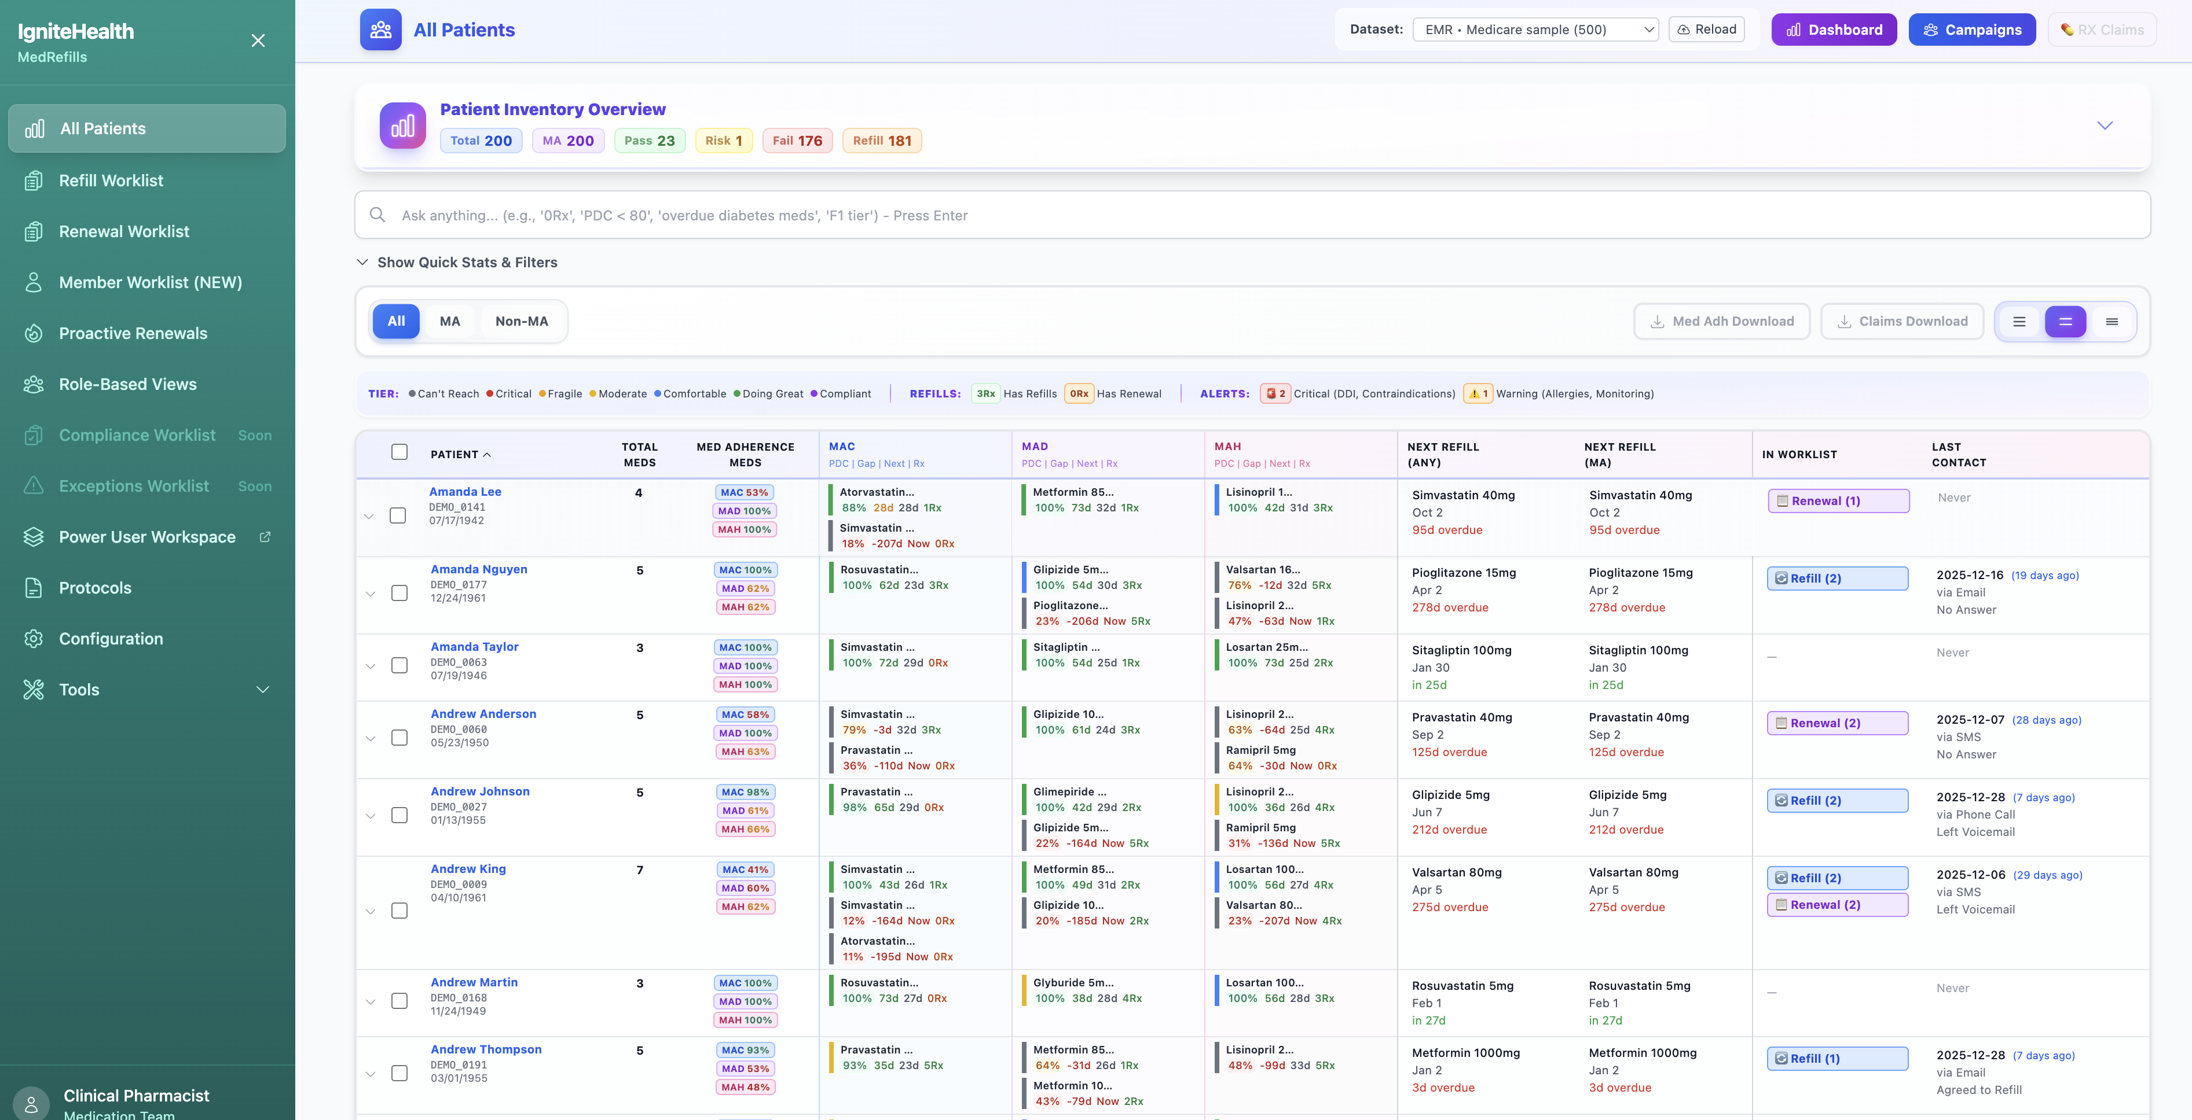

PATIENT DETAILS

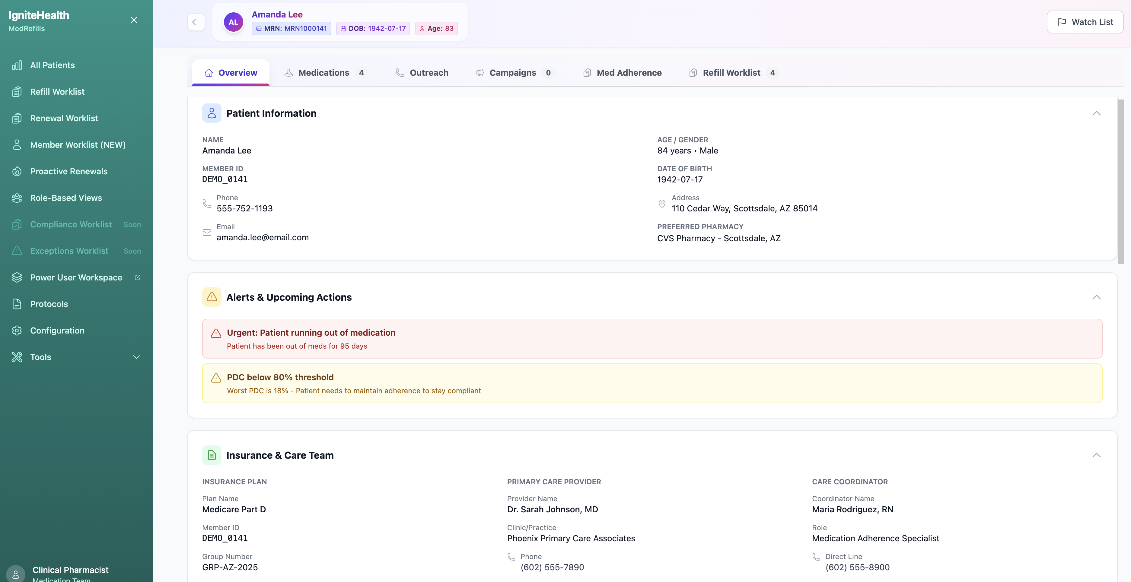

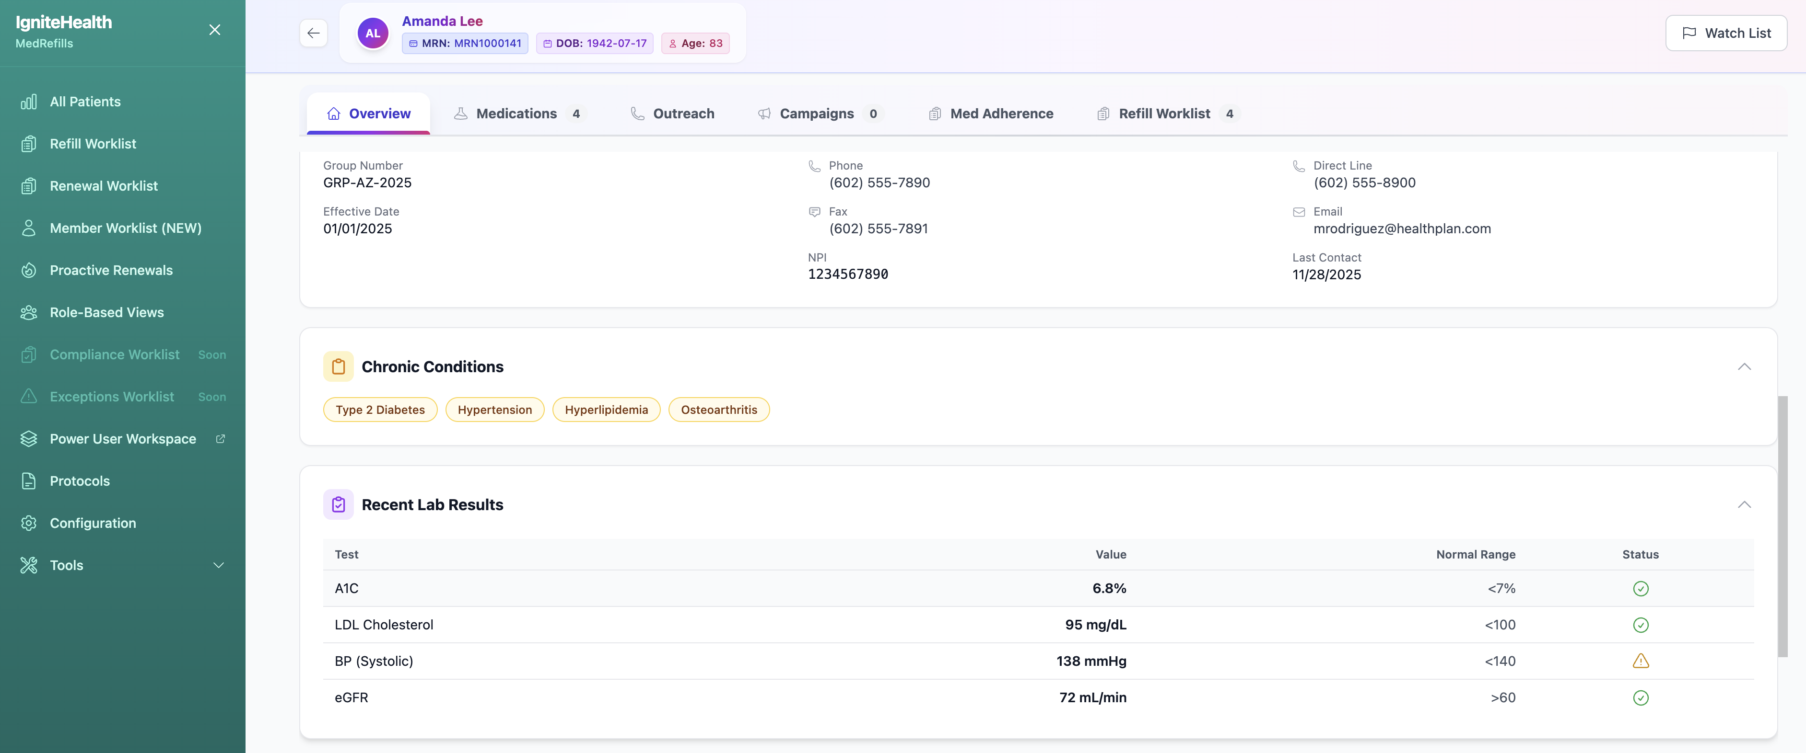

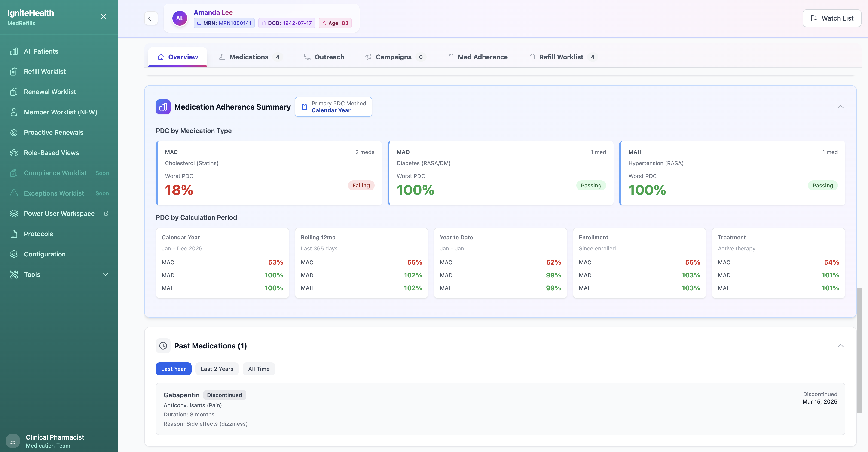

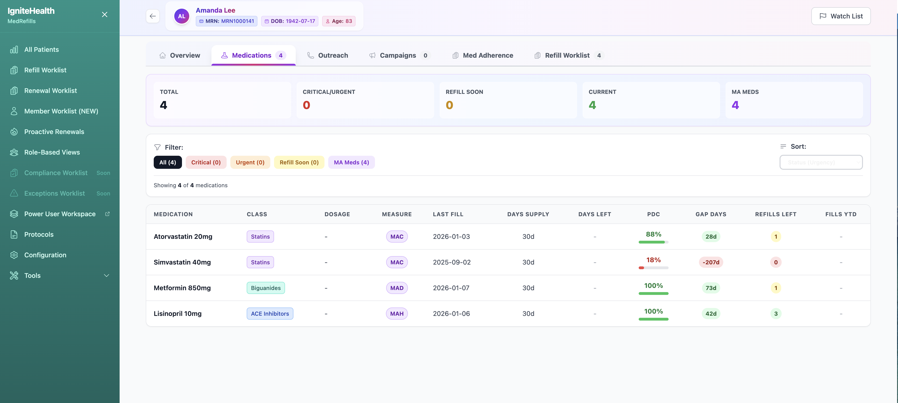

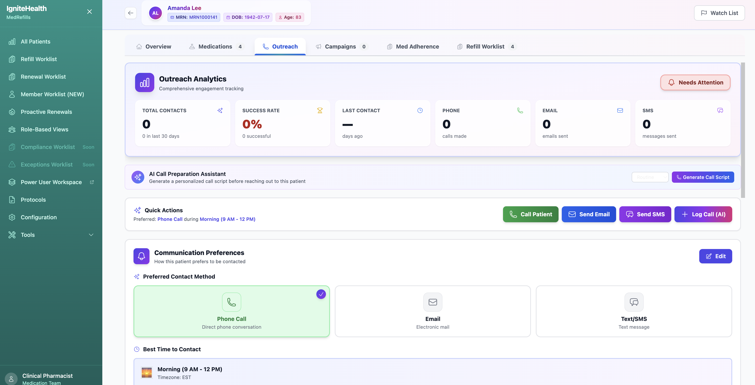

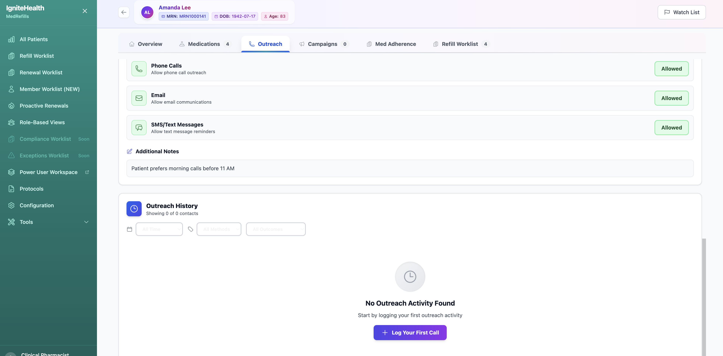

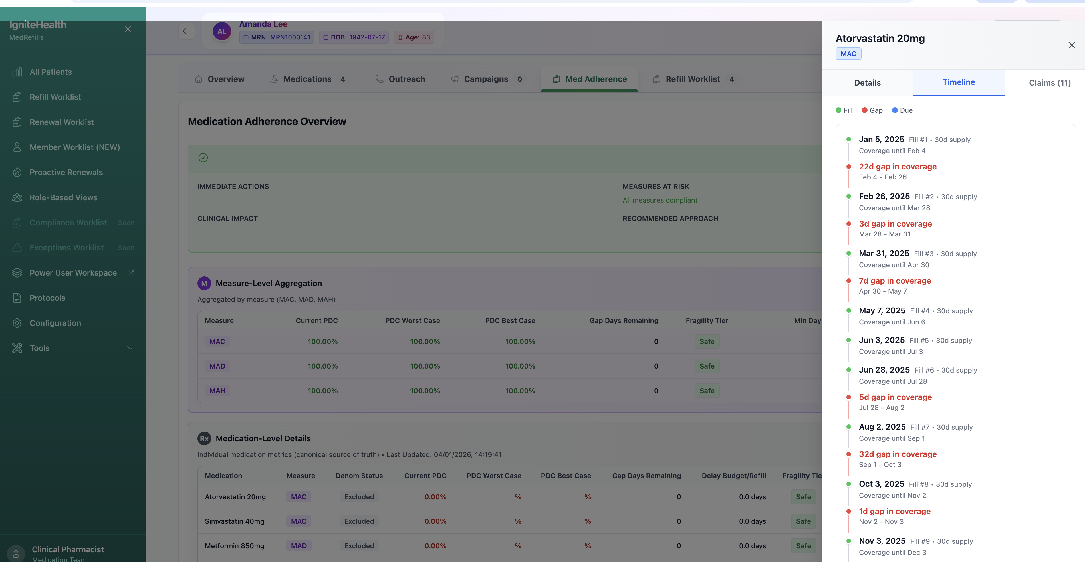

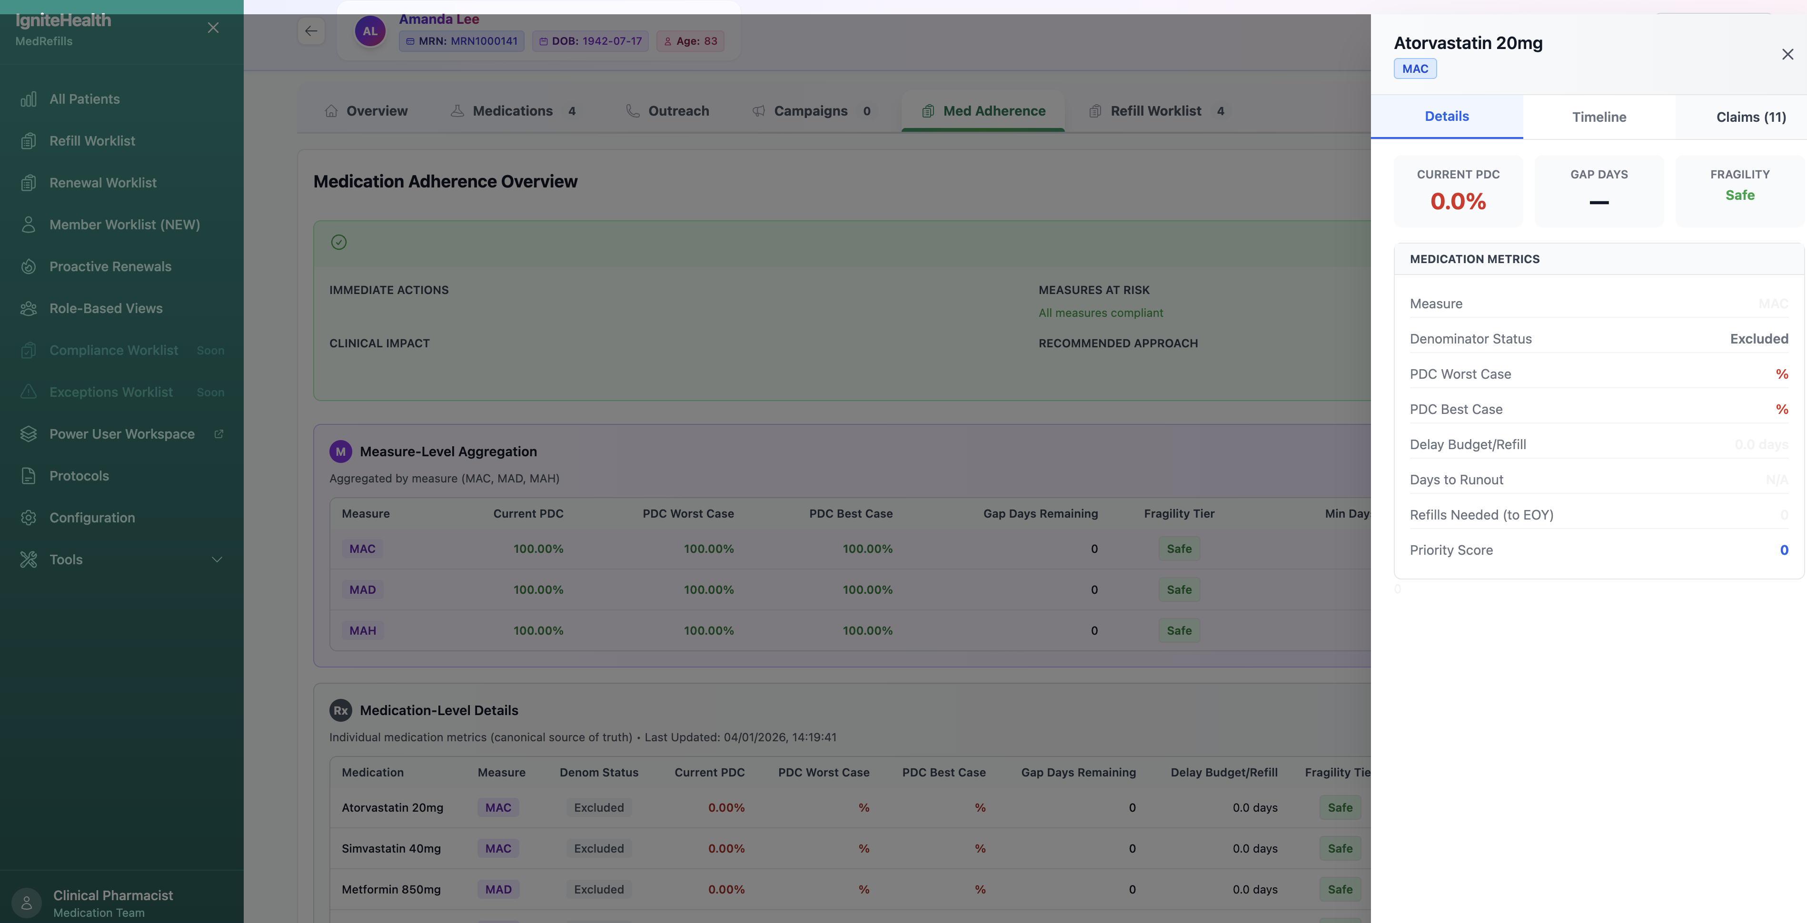

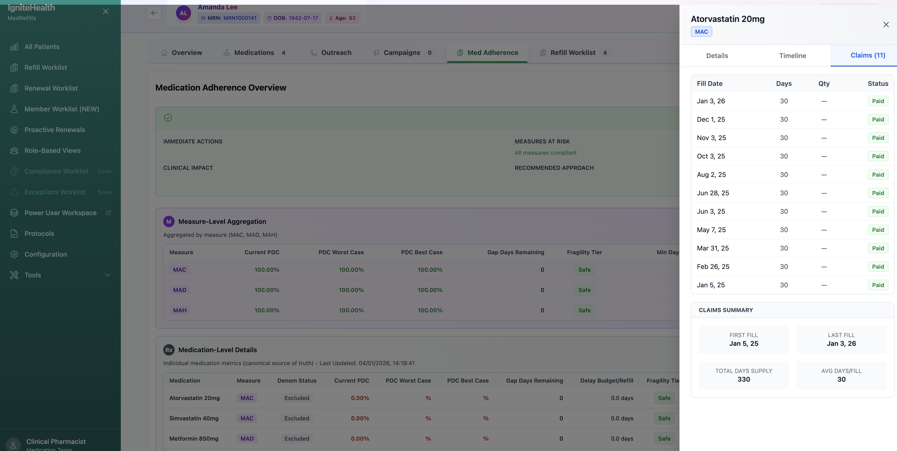

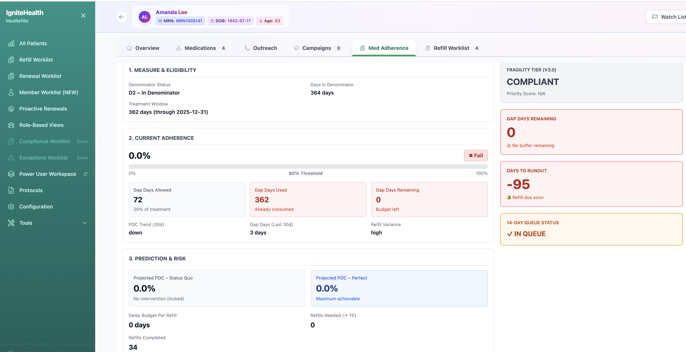

REFILL WORKLIST

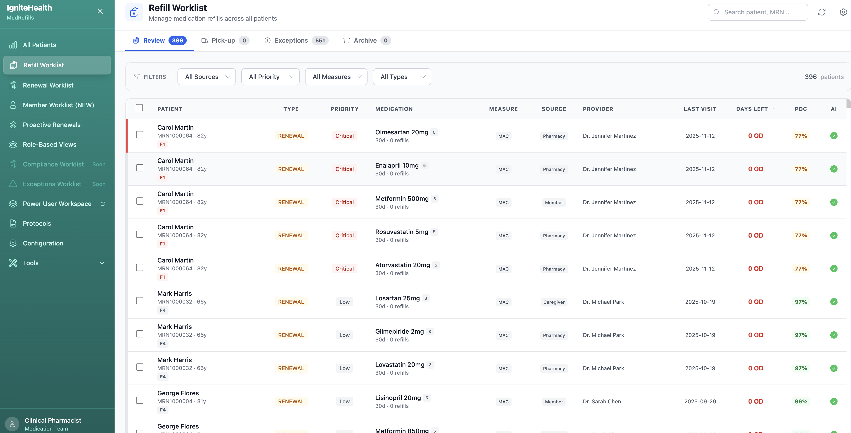

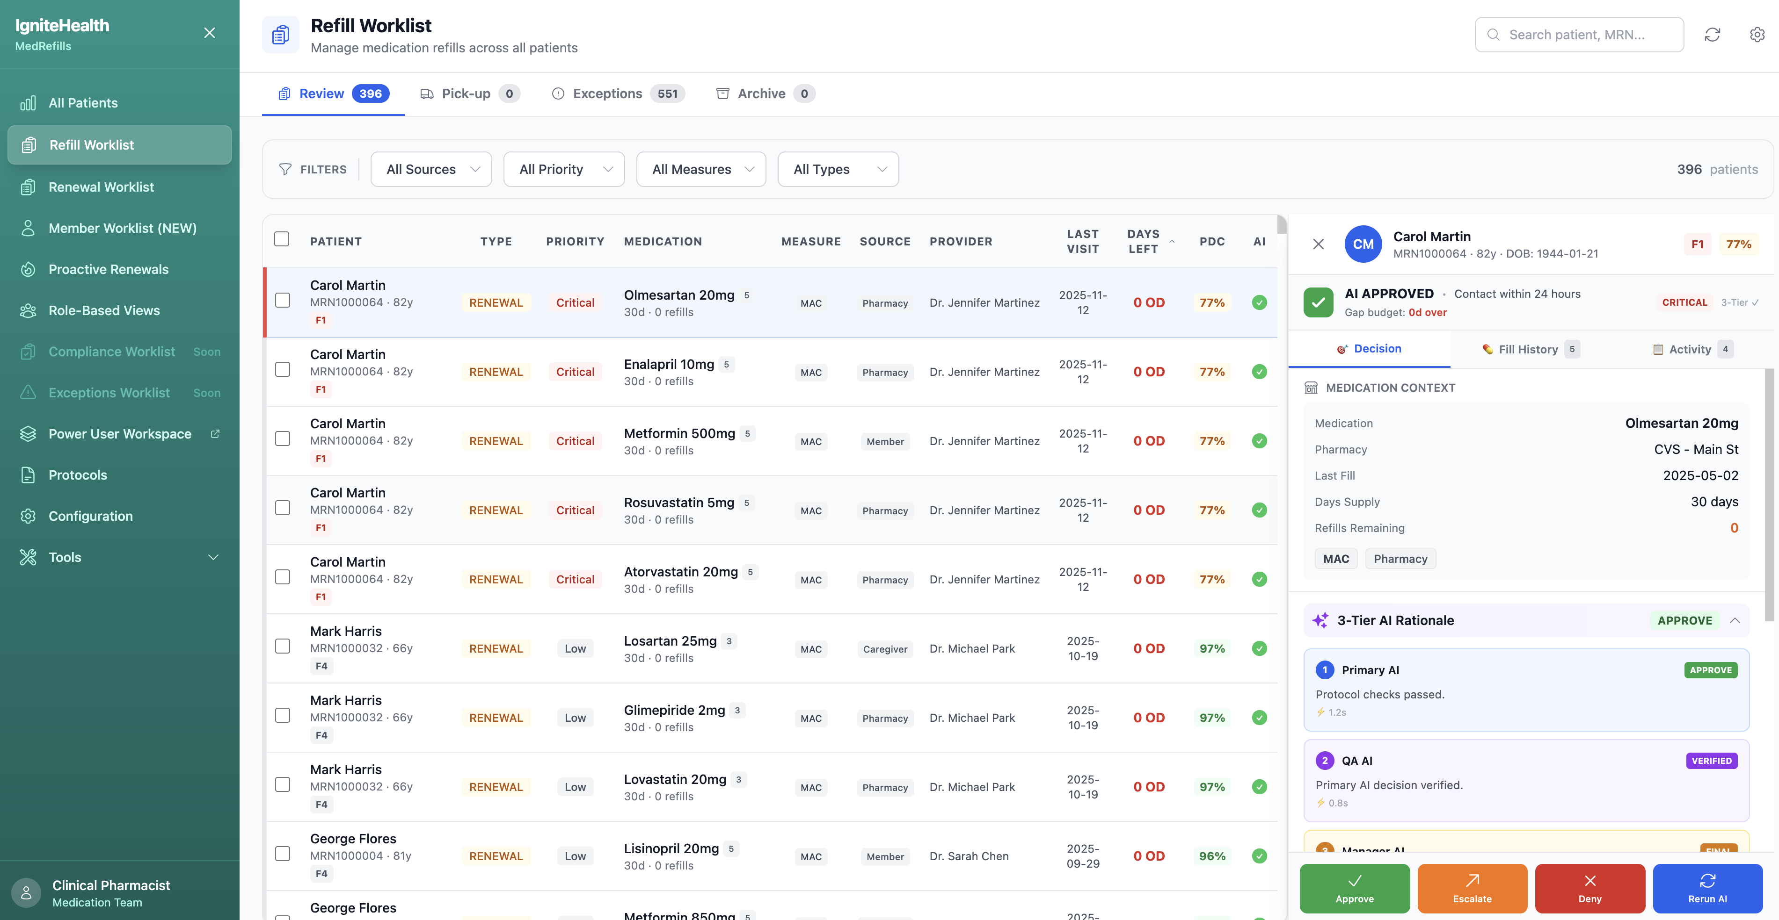

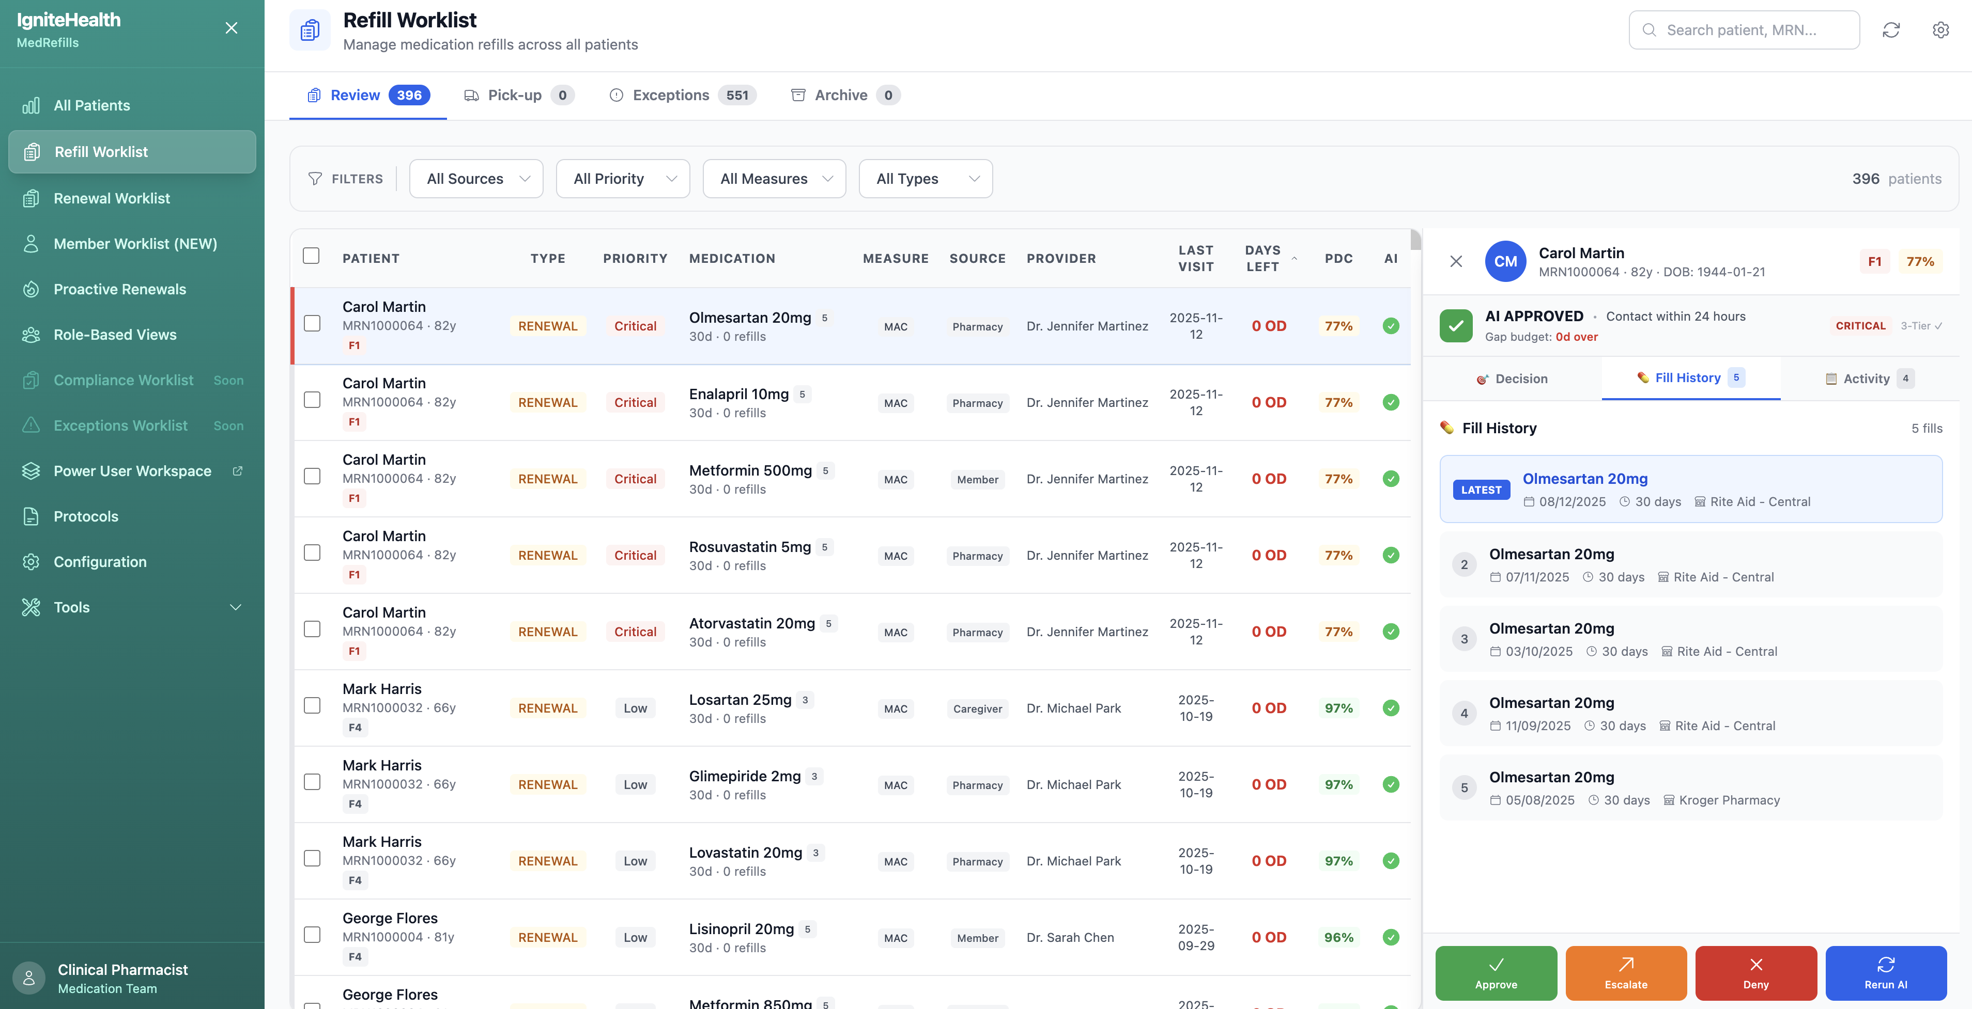

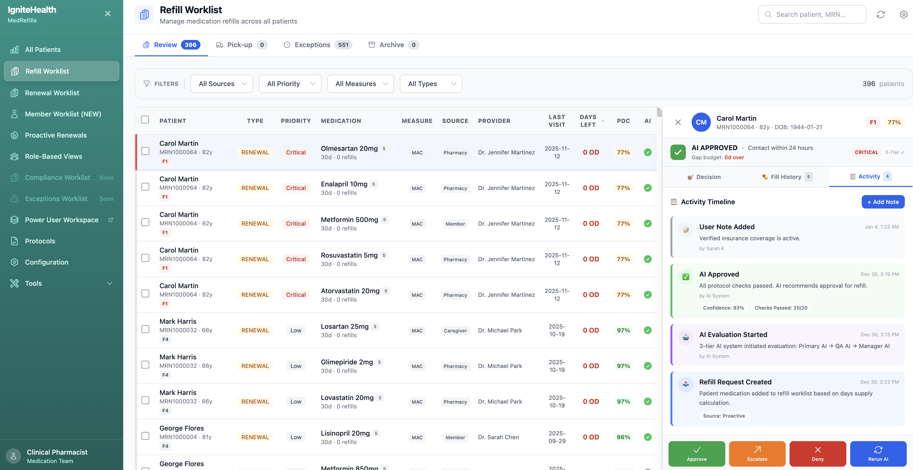

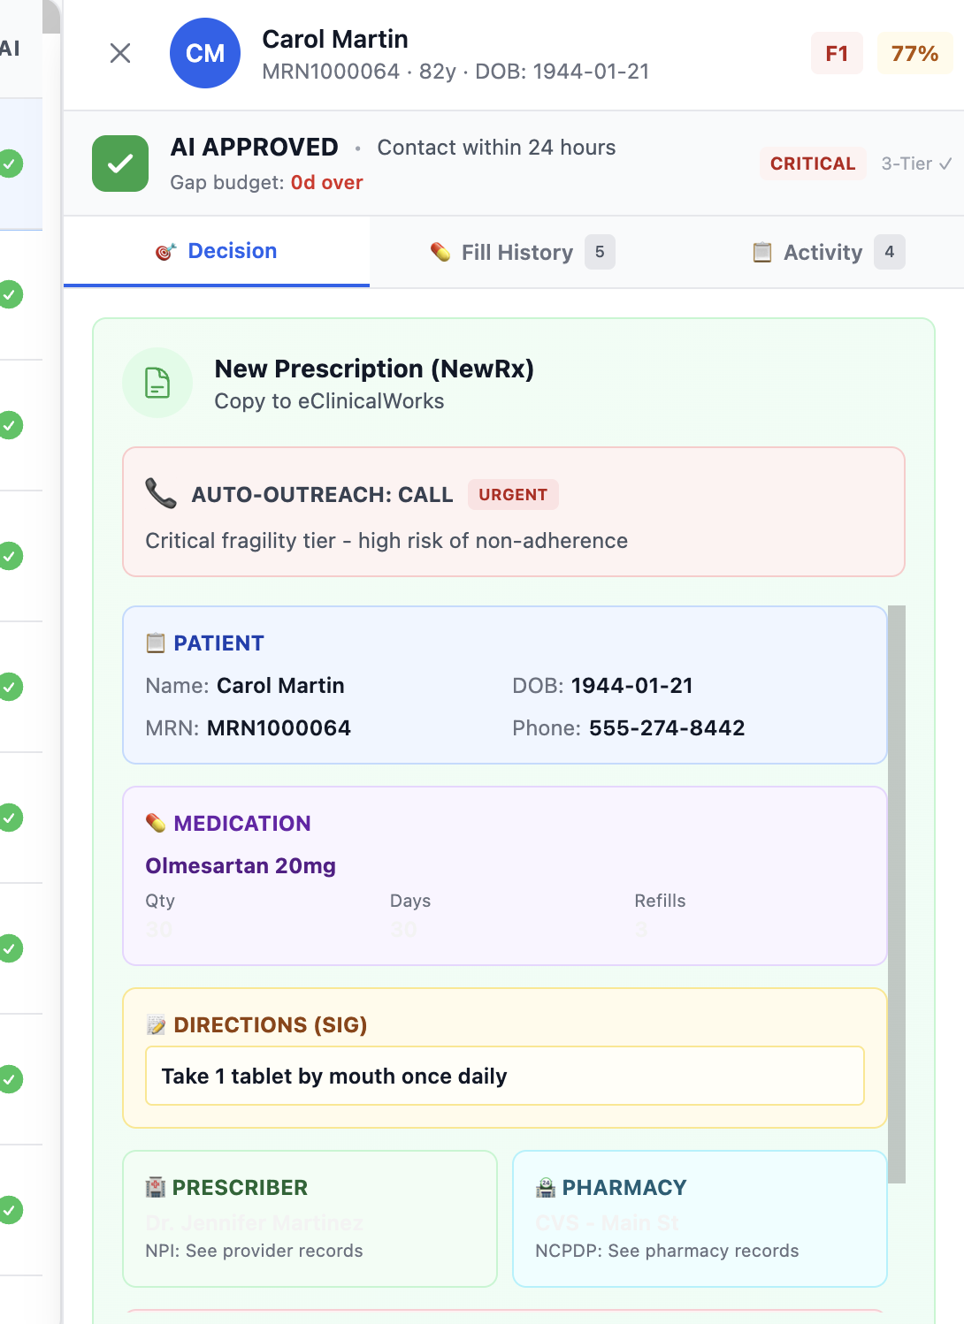

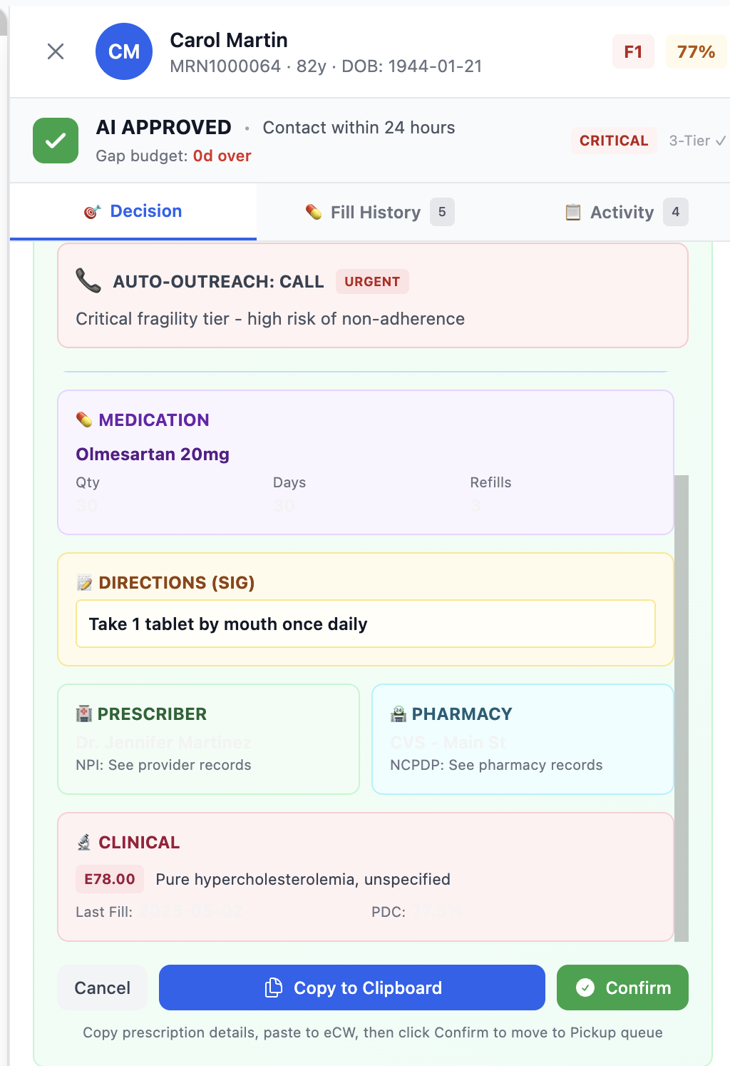

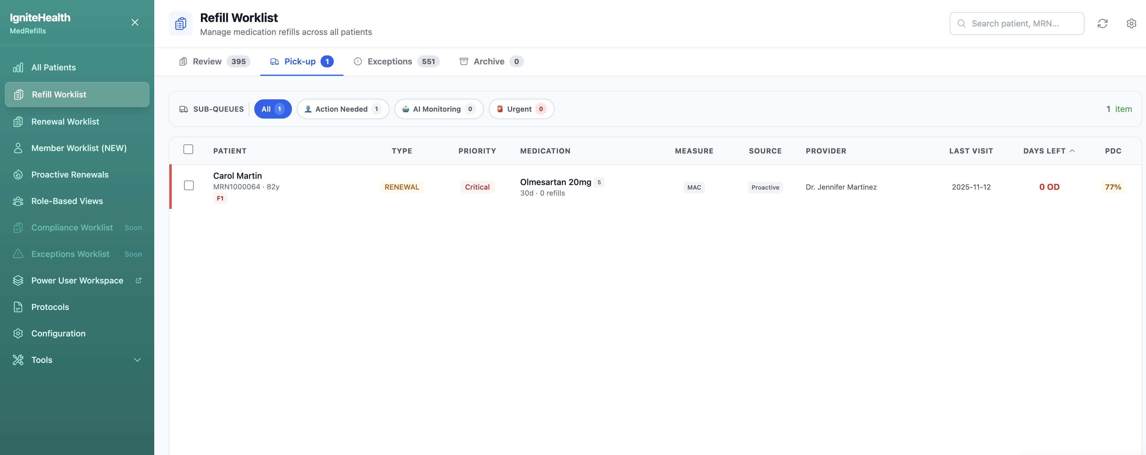

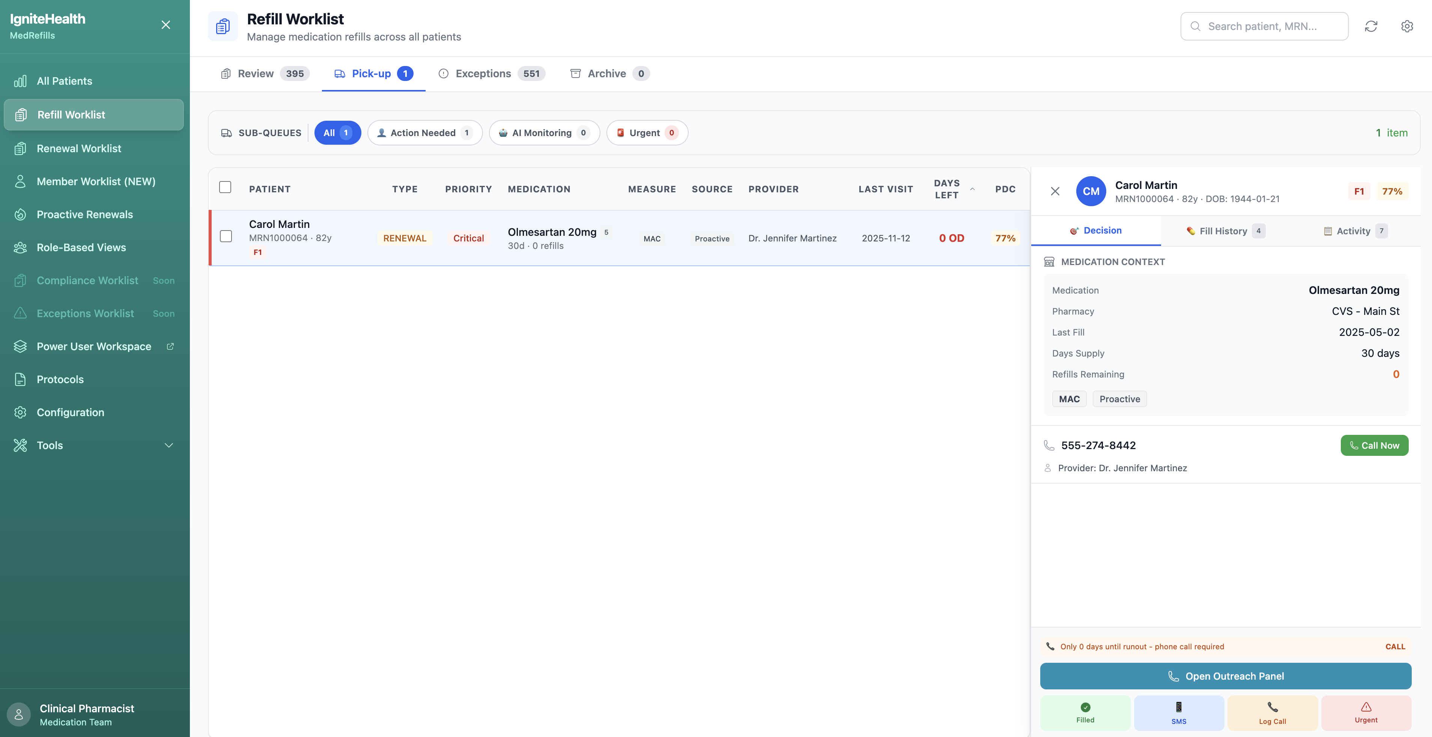

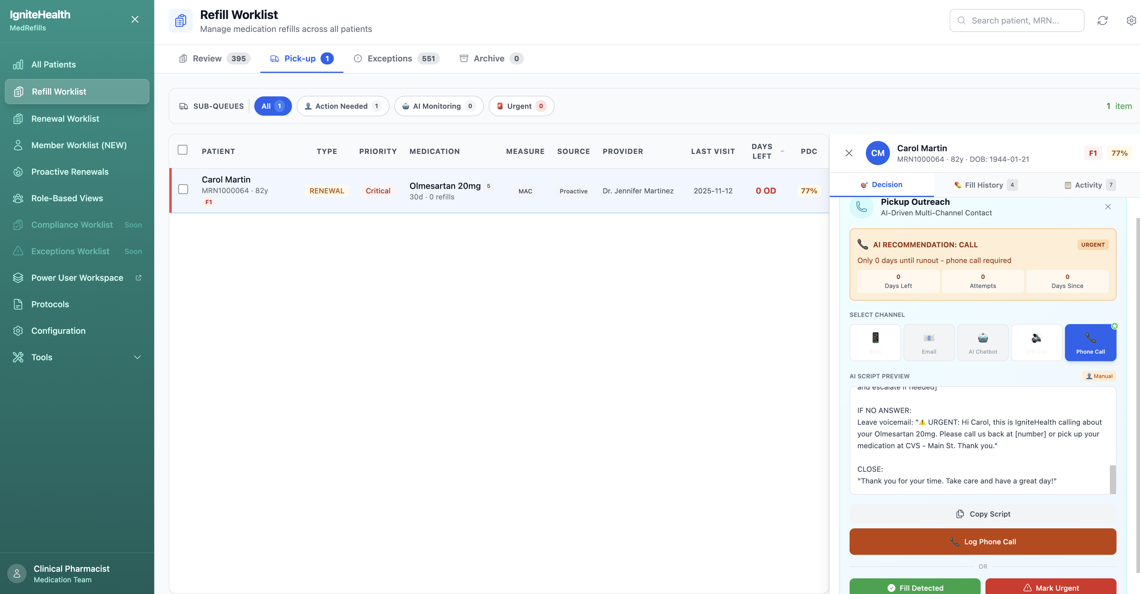

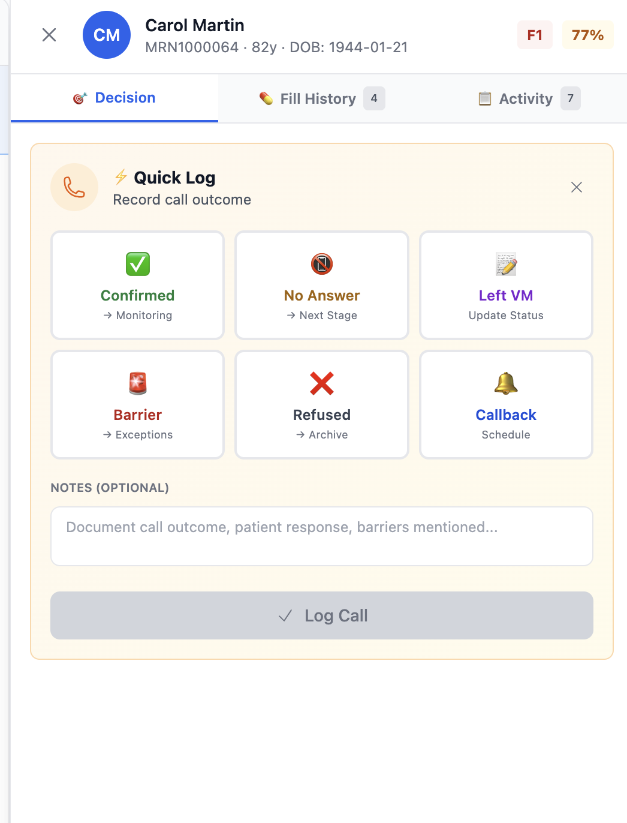

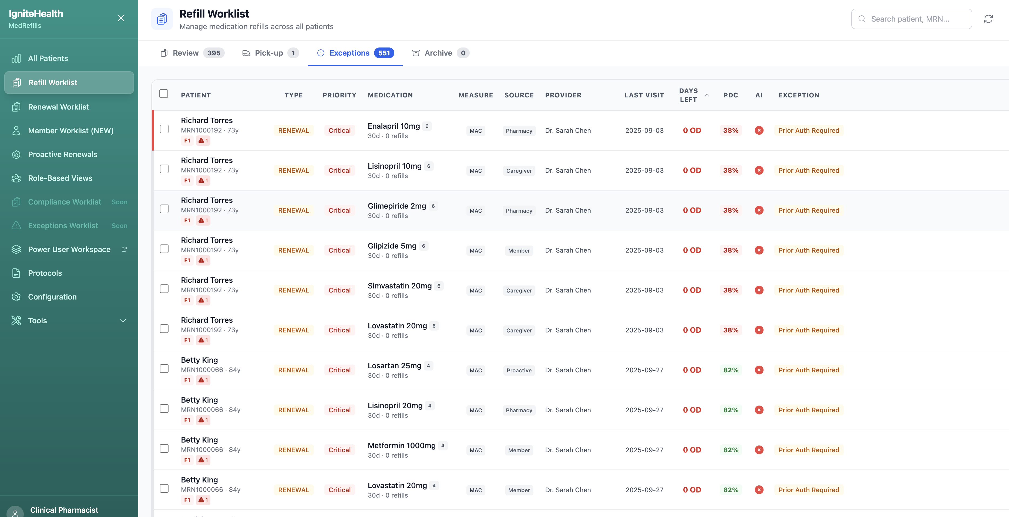

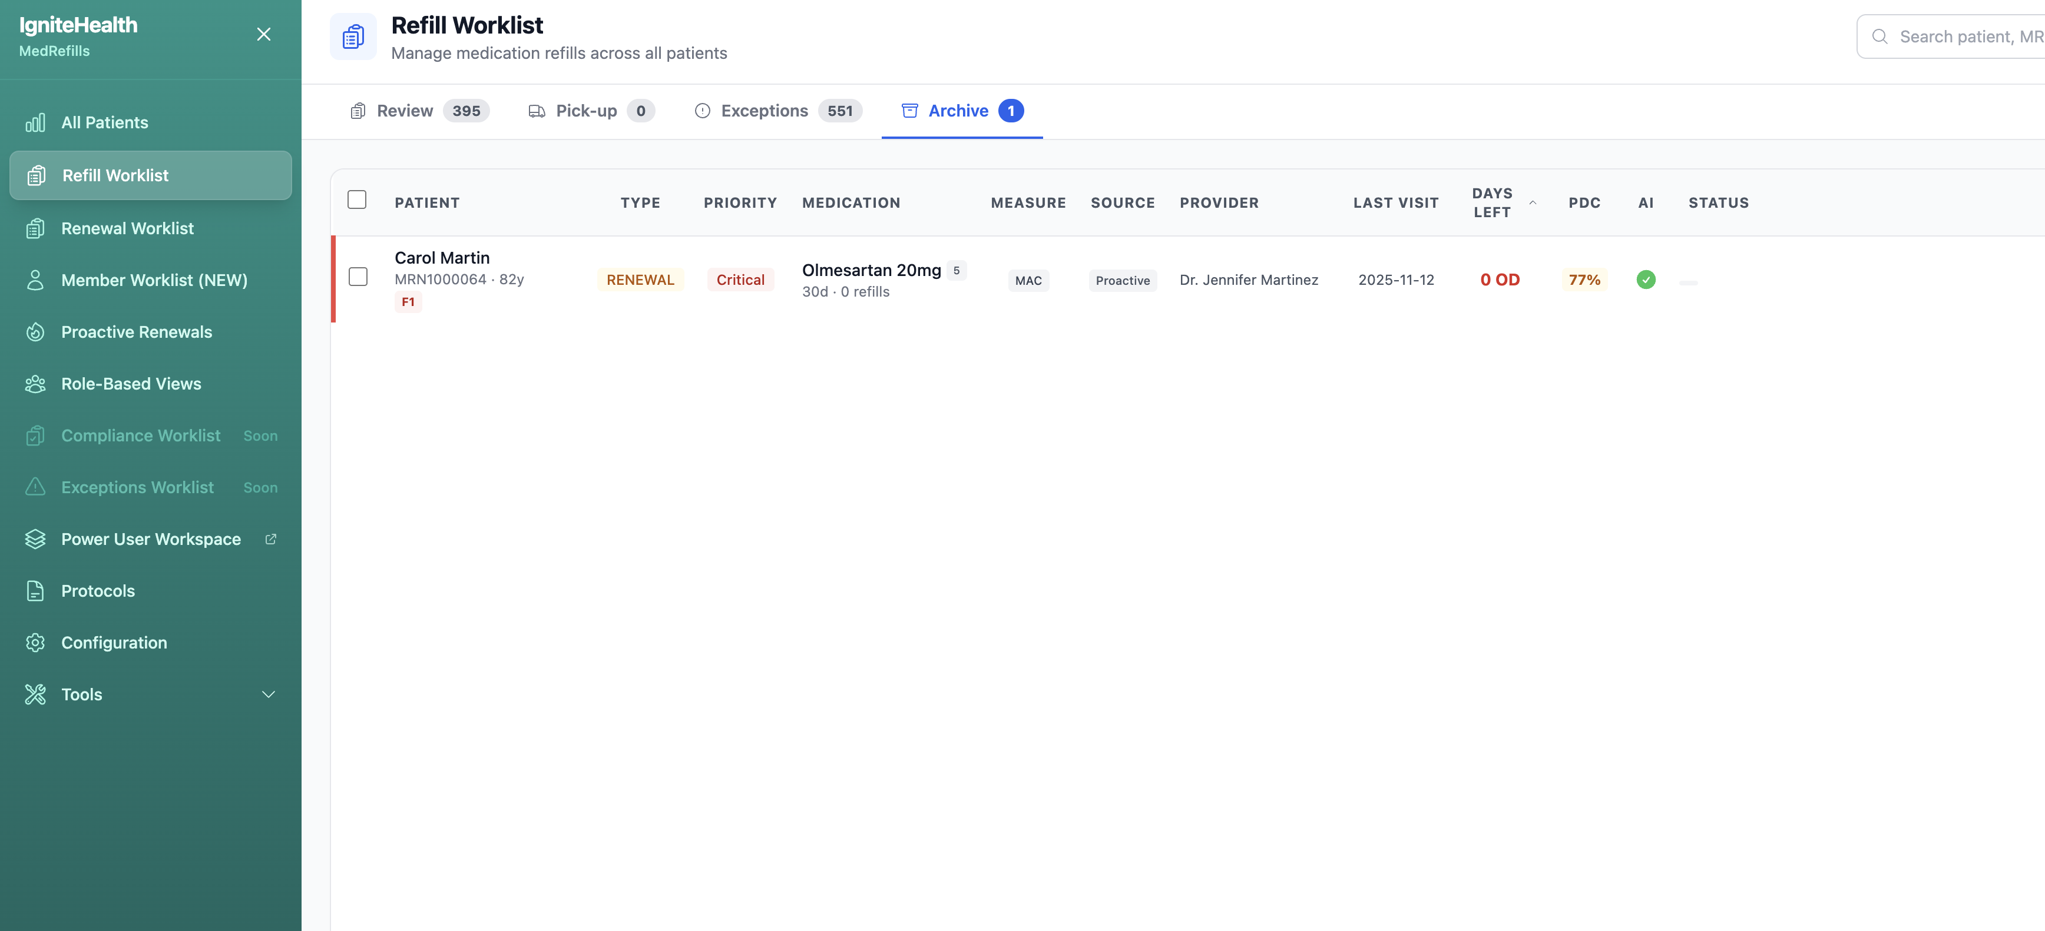

## Document Control

| Field | Value |
| --- | --- |
| **Document Owner** | Product Head |
| **Review Cycle** | Quarterly |
| **Next Review** | April 2026 |
| **Distribution** | Engineering, Product, Clinical, Leadership |

*This PRD is the authoritative source for product requirements. All development and design decisions should reference this document.*

*Last Updated: January 3, 2026*